Uniweb Amigos Group Report

COMP-1640-M02-2016-17 - Enterprise Web Software

Authors:

Donaldas Petkus

ID: 000941788-5

Username: dp6735y

Onyemaechi Ileke

ID: 000749088

Username: lo206

Steven Neal

ID: 000942159-9

Username: sn3590r

Ben Witchell

ID: 000942552-7

Username: bw6609t

Lopei Sawyers

ID: 000863250

Username: sl7406l

Martin Whitford

ID: 000959662-3

Username: mw6886l

Glossary 4

Management Summary 5

Assumptions 6

Website Requirements 6

User Stories 6

Universal to All 6

Guests 6

Student User Group 6

Market Coordinator User Group 7

Market Manager User Group 7

Admin User Group 8

MoSCoW Analysis of User Stories 9

Must Have 9

Should Have 9

Could Have 10

Website Functionality vs. User Stories 11

**Universal to All** 11

**Student User Group** 11

**Market Coordinator User Group** 11

**Market Manager User Group** 12

**Admin User Group** 12

Website Functionality 13

User Levels, Role-Based Security & Access Privileges 13

Report Submission 14

**User Submitted Reports** 14

**Exception Reports & Validation** 15

Inbuilt Email and Notification System 16

External Email Client 16

Site Design 17

Wireframes & Mock-ups 17

**First Pass Mock-ups** 17

**Second Pass Wireframes** 19

Wireframes Redux 23

Responsive Design Principles 31

Mobile Accessibility 31

Mobile View 31

Accessibility Features 36

Text to Speech Capabilities 36

House Style & Colour Choices 37

Colour Scheme 37

**Bright blue (#2EA3F2)** 37

**Very Dark Grey 1 (#666666)** 38

**Very Dark(er) Grey 2 (#222222)** 39

**Project Logo Design** 40

Inspirations & Assets 40

First Design Batch 41

Final Design 42

Database 43

ERD Diagram 43

Testing 44

Test Plan 44

Test Log 45

Marketing Manager 45

Marketing Coordinator 45

Administrator 46

Guests 46

Students 47

Database 47

Appendix 48

System Access Details 48

**User Components:** 48

**Website Components:** 48

User Account Details 48

**Students:** 48

**Marketing Coordinators** 49

**Marketing Manager:** 49

**Administrator:** 49

**Master Administrator:** 49

**Subscriber:** 49

Charts & Diagrams 50

**Gantt Chart** 50

**Burndown Chart** 51

Sprints 52

Sprint One (Week One) 52

Sprint Two (Week Two) 52

Sprint Three (Week Three) 52

Sprint Four (Week Four) 52

Sprint Five (Week Five) 52

Sprint Six (Week Six) 52

Sprint Seven (Week Seven) 52

Meeting Minutes 53

**Meeting 1** 53

**Meeting 2** 55

**Meeting 3** 57

**Meeting 4** 59

**Meeting 5** 61

**Meeting 6** 63

**Meeting 7** 65

**Meeting 8** 67

Website Privacy Policies 69

Figures 70

# Glossary

**MoSCoW:** A method of prioritisation to which functions are divided up based on a level of need; M(ust have), S(hould have), C(ould have) and W(on’t have).

Ultimately items within the must have are to be implemented on first pass as a first priority due to being imperative for basic operation of the product.

Should haves are secondary functions whose value has been noted, and can be added if time permits, a could have is tertiary, something that will likely be postponed until later in the development. Won't have is a bracket for features that are deemed unrelated, too costly or generally unfit for the current context or purpose for development, set aside for future iterations.

**#FFFFFF (Hex Codes):** A hex colour designation, used for selecting specific colours of a tone, shade and tint for use in computer oriented graphical design. #FFFFFF (or #FFF) refers to a pure white or blank colour, whereas #000000 (or #000) refers to a complete black. Hex codes use both numbers and characters to describe a particular colour.

**Monochromacy:** Monochromatic vision refers to one who suffers from a severe colour perception deficiency, being only able to see one pure colour, depending on the subcategory this ranges from sepia to greyscale.

**Dichromacy & Trichromacy:** Similar to Monochromacy, however the viewer is able to perceive two or three pure colours or having two or three channels for colour perception respectively.

# Management Summary

Documented is the following process of design and testing for the elements incorporated into the Uniweb Amigos’ prototype submission; focusing around the available assets present within the teams development repository.

Included segments illustrate the motions take by Uniweb to meet the demands and requests stipulated by the design brief, including assumptions and development of an understanding of the users and their potential activities in the form of user stories to express these as functions.

Project analysis comprises of brief MoSCoW allocation for priority elements of the website for immediate production, followed by an analysis of the aforementioned needs of the users against a finished product.

Leading on from the requirements are the implemented features and functions available by the Uniweb Amigos prototype; defining the role based security of accounts and flexible user levels controlled by the privileges of accounts found higher in a pyramid or hierarchy.

Site design comprises a collection of motions and aspects featured by the prototype, beginning with several sets of wireframes and drafts, fleshing out possible avenues for design and functionality. Screenshots have been provided to the later stages of development to exemplify the incorporation of responsive design techniques and an attention to detail regarding the wellbeing of the sites user base, such as colour scheme decisions for a house style. Also included are some pages dedicated to the team and websites logo submission, along with a simplified ERD diagram describing the relations between accounts within the sites database structure.

Testing of the site has been documented throughout the production of the prototype under a brief test plan found the near the end of the document.

An appendix has been provided to incorporate the charts and supporting details of the prototype and the Uniweb Team, which allow access for users to test the website for themselves across all aspects from subscriber to master admin and beyond.

# Assumptions

“Will the users be of various demographics?”

* Students and other users may be hard of sight, or have other disabilities preventing full use of a website.
* Users might be of a wider range of ages, and will need to be accounted for.

“How will the system deal with unregistered users?”

* Preventing users from being able to access the site purely to view articles without logging in, ala sites like GitHub and recently Facebook or Pinterest, might significantly reduce site traffic.
* Allowing having basic open access rights to non-registered entities to approved features would likely lead to more enthusiasm in using the website.

# Website Requirements

## User Stories

In order to understand the requirements provided by the client in a practical sense, the brief is interpreted into a segmented grouping of requests, or *‘user stories’*; designed to assist in fleshing out the functional aspects of the product for easier progression onto functional analysis and ‘MoSCoW’ prioritisation.

These user stories are written in a *‘WHO*(*is it for)*, WHAT*(*do they need to do)*, WHERE*(*do they need to be able to do it)*’* format to illustrate the defining of functions that may have a role in future iterations of the product.

### Universal to All

1. Login*
2. Account recovery*
3. Degrees of security*

### Guests

1. I want to have access to selected articles, so I could read them.
2. I need this web application to be responsive, so I could access it from all devices, including a mobile phone or a tablet.

### Student User Group

1. I need to be able to login as a Student, so I could access the dashboard on this web application, control my account and use my privileges.
2. I need to be able to change my password and other details on the dashboard, such as address or a phone number, because this information may change.
3. I need to have a “Reset Password” link on the login form, which would allow me to reset my password in case I would forget it.
4. I need to have access to “Upload Your Report” link, so I could send my article.
5. I need to have access to “Upload Images” link, so I could send high quality (and large size) images.
6. I need to be able to submit more than one article or image, because I may have multiple articles or images.
7. I need to be able to edit my articles before the closure date, because I may want to do changes before the final closure.
8. I need this web application to be responsive, so I could access it from all devices, including a mobile phone or a tablet.

### Market Coordinator User Group

1. I want students to agree to Terms and Conditions before they submit their articles, so they would be aware of the submission rules.
2. I need to receive an email notification when a new contribution within my faculty was submitted, so I would become aware of it.
3. I need to be able to login as a Marketing Coordinator, so I could access the dashboard on this web application, control my account and use my privileges.
4. I need to be able to change my password and other details on the dashboard, such as address or a phone number, because this information may change.
5. I need to have a “Reset Password” link on the login form, which would allow me to reset my password in case I would forget it.
6. I need to have an access to all submissions within my faculty, so I could manage them.
7. I need to be able to manage submissions in order to select those for publication.
8. I need to be able to leave a comment on submissions, so that students would know what needs to be edited on their submissions.
9. I need all submissions to be separated and marked in 4 different ways, according to their importance, so I could focus on the most urgent submissions:
   1. Submissions, which have already received my comment (e.g. Green colour).
   2. Submissions, which have not received my comment yet, but are still within 14 days of the deadline (e.g. Yellow colour).
   3. Submissions, which have not received my comment yet and are already out of 14 days of the deadline (e.g. Red colour).
   4. Submissions, which have already received a comment and are selected for publication (e.g. Blue colour).
10. I need to be able to filter all submissions by their importance mark, so I could filter out submissions, which have already received a comment or have been selected for publication.
11. I want students to not be able to submit any new submissions after the closure date, so that they would not get mixed up with already submitted ones.
12. I want students to be able to edit their submissions before the final closure date, so they could edit their submissions before the publication.
13. I need this web application to be responsive, so I could access it from all devices, including a mobile phone or a tablet.

### Market Manager User Group

1. I need to be able to login as a Marketing Manager, so I could access the dashboard on this web application, control my account and use my privileges.
2. I need to be able to change my password and other details on the dashboard, such as address or a phone number, because this information may change.
3. I need to have a “Reset Password” link on the login form, which would allow me to reset my password in case I would forget it.
4. I want Marketing Coordinators to see submissions only within their faculties, so they would not interact with other faculty’s submissions.
5. I want to see all submissions from all faculties, so I could manage them.
6. I need to see all submissions on the dashboard, which should be separated in 4 different ways, according to their current status, so I could deal with them accordingly:
   1. Submissions, which have already received a comment by Marketing Coordinators (e.g. Green colour).
   2. Submissions, which have not received a comment from Marketing Coordinators yet, but are still within 14 days of the deadline (e.g. Yellow colour).
   3. Submissions, which have not received a comment from Marketing Coordinators yet and are already out of 14 days of the deadline (e.g. Red colour).
   4. Submissions, which have already received a comment and are selected for publication (e.g. Blue colour).
7. I need to be able to download all selected submissions in a single ZIP file, so I would have all submissions inside one file.
8. I need to see statistics, so I could produce a report about:
   1. Number of submissions within each Faculty for each academic year;
   2. Percentage of submissions by each Faculty for any academic year;
   3. Number of submissions within each Faculty for each academic year.
9. I need this web application to be responsive, so I could access it from all devices, including a mobile phone or a tablet.

### Admin User Group

1. I need to be able to login as an Administrator, so I could access the dashboard on this web application, control my account and use my privileges.
2. I need to be able to change my password and other details on the dashboard, such as address or a phone number, because this information may change.
3. I need to have a “Reset Password” link on the login form, which would allow me to reset my password in case I would forget it.
4. I need to have an access to the user's control panel, so that I would be able to create, edit or remove accounts.
5. I need to be able to change roles (Student, Marketing Coordinator, Marketing Manager or Administrator) for new accounts, so I could set different privileges for different users.
6. I need access to the system data, so I could set closure dates for each academic year.
7. I need this web application to be responsive, so I could access it from all devices, including a mobile phone or a tablet.

## MoSCoW Analysis of User Stories

For this project the requirements have been deemed as a

### Must Have

* **Universal**
* Administrator to be able to create edit and delete accounts and set roles for each user.
* All login need to be created for each of the users (Students, Marketing Manager, Marketing Coordinator, Administrator)
* Each account needs to be able to change their details when they login from passwords to phone numbers and other details.
* **Student User Group**
* As student, they would need to have upload image links and upload file links and can upload multiple files.
* **Coordinator User Group**
* As a marketing coordinator, there needs to be able to comment on any student submission made and have 14-day time to comment.
* **Manager User Group**
* As a marketing manager, there needs be a way to see all submissions made and how long they haven’t had a comment from the marketing coordinator for.
* **Administrator User Group**
* As an administrator, there needs to be a way of showing users when they login of when they were last logged in for security reasons
* As Administrator, I need access to the system data, so I could set closure dates for each academic year.
* Administrator to be able to create edit and delete accounts and set roles for each user.

### Should Have

* **Student User Group**
* As a student, there needs to be a way to edit submissions before its closure date.
* **Coordinator User Group**
* As a marketing coordinator, there needs to be a way of them to receive an email when a new submission within their faculty has been made.
* As marketing coordinator, there needs to be access to view all submissions made within their faculties, so they do not interfere with another faculty’s.
* **Manager User Group**
* The marketing manager will need to see all submissions made for each faculty.
* As marketing manager, there needs to be a way of seeing the statistics of the site from the number of submissions made to percentages of the faculty’s that made the submissions etc.

### Could Have

* **Guests**
* As a guest, there need to be a way to view articles so they are able to read them.
* **Coordinator User Group**
* As marketing coordinator, there needs to be a way for the students to agree to the terms and conditions before making a submission.
* **Manager User Group**
* As marketing manager, there needs to be a way of downloading all selected submissions into a zipped folder.
* **Administrator User Group**
* As Administrator, there needs to be able to receive a report of statistics on most active users most pages visited etc.

## Website Functionality vs. User Stories

### **Universal to All**

*“I need to be able to login as a “____”, so I could access the dashboard on this web application, control my account and use my privileges.”*

* Each user has their own account with personal dashboard for activities relevant to the operations and responsibilities of their user group.

*“I need to be able to change my password and other details on the dashboard, such as address or a phone number, because this information may change. & I need to have a “Reset Password” link on the login form, which would allow me to reset my password in case I would forget it.”*

* Edits of this kind are available via a settings tab on an individual’s profile page, as well as this, the option to change password is possible via the login screen.

*“I need this web application to be responsive, so I could access it from all devices, including a mobile phone or a tablet.”*

* The website is available in both mobile and home browser forms for convenient usage from most locations.

### **Student User Group**

*“I need to have access to “Upload Your Report” link, so I could send my article.”*

*“I need to have access to “Upload Images” link, so I could send high quality (and large size) images.”*

*“I need to be able to submit more than one article or image, because I may have multiple articles or images.”*

* The ability to upload articles is the main function of the student user; the upload operation allows the user to provide multiple items of various types (.docx, .jpg, .png etc.) providing they are valid under the terms and conditions and are not an executable format. Images are uploaded as they are, with the quality stipulated by the user.

*“I need to be able to edit my articles before the closure date, because I may want to do changes before the final closure.”*

* Users are able to; once a file has been uploaded to the listing, edit the name of a file before it is submitted for consideration.

### **Market Coordinator User Group**

*“I want students to agree to Terms and Conditions before they submit their articles, so they would be aware of the submission rules.”*

* The system meets this requirement as users must check a box acknowledging the terms and conditions for being able to submit files for hosting.

*“I need to receive an email notification when a new contribution within my faculty was submitted, so I would become aware of it.”*

* The Coordinator dashboard features the uploads of students from within their assigned faculty, providing details of said uploads via notification; account notifications are distributed to an external email client available at <https://pastas.serveriai.lt/>

*“I need to have an access to all submissions within my faculty, so I could manage them.”*

*“I need to be able to manage submissions in order to select those for publication.”*

*“I need to be able to leave a comment on submissions, so that students would know what needs to be edited on their submissions.”*

* Coordinator accounts have access to a dashboard filled with the directories of users within their faculty; the ability to sort, filter and edit the files in each of these directories is possible without hindrance due to their accounts privilege level.

### **Market Manager User Group**

*“I want to see all submissions from all faculties, so I could manage them.”*

* As with the coordinator account, a dashboard is presented with directories to all faculties, which enables to viewing of articles and submissions present in those directories.

*“I need to be able to download all selected submissions in a single ZIP file, so I would have all submissions inside one file.”*

* While not a feature unique to this user, the ability to bulk download items from the file browser is possible with the functions implemented at the bottom of the browser and are actionable once activated by a prompt, users must then select the articles they want, and how they wish to act on them from the menu provided.

*“I need to see statistics, so I could produce a report about:*

1. *Number of submissions within each Faculty for each academic year;*
2. *Percentage of submissions by each Faculty for any academic year;*
3. *Number of submissions within each Faculty for each academic year.”*

* The user is able to utilise a form of analytics feature from their dashboard that collects the data provided.

### **Admin User Group**

*“I need to be able to change roles (Student, Marketing Coordinator, Marketing Manager or Administrator) for new accounts, so I could set different privileges for different users.”*

* The system meets this requirement, admin and master admin account classes have complete vision over the activities of all user groups, and may edit any account at any point in time, whether it is to elevate their rank, or change their password.

*“I need access to the system data, so I could set closure dates for each academic year.”*

* Admin user classes have access to site demographics and analytics from their dashboard, this feature sums up their control over the site, being able to view logins, uploads, comments and alterations made by those in lower ranked user groups.

# Website Functionality

## User Levels, Role-Based Security & Access Privileges

Users are split into categories based on the functions relevant to their account and are granted privileges from their account rank; the master administrator is able to alter user ranks at will. Guests are the most restricted form of user, not fully registered with the website, and do not have any form of controllable account; users of this category are purely observers to the site and may only have access to the select articles.

Subscribers are the lowest form of affiliated user group; they do not have an actionable control over the site, but have the option to be given higher user status with the permission of the admins.

Student is the lowest actionable level of user, students may fulfil their primary operation of uploading files to the site for moderation, but also have access to forums, inter account communications and commenting, on top of other open access features. Their restriction is that they may only upload their files to the faculty that they have been assigned to.

Marketing coordinators are the lowest form of management account, acting as supervisor to a single faculty, with operations centred on moderating the activities conducted by Students of their faculty regarding uploads; coordinators may edit, remove and approve files for use in a volume of the product newspaper or magazine.

The Marketing manager is the second tier of management, with the capacity to control the activities of all faculties; the manager is required to supervise the activities of coordinators, and serves as the main authority for publishing articles.

Administration is handled by the Admin and Master Admin classes, these high level users control most and all respectively; Admin, or admin lower has general authority over all aspects of the sites management from user account editing, the control of semester and relevant upload deadlines

## Report Submission

### **User Submitted Reports**

Figure 1 - Student Dashboard

Student users are presented with an activity screen for uploading files to the system, along with all files that the user has uploaded in a table. Addition of new files is possible via the use of the upload panel. New files must be compliant with the terms and conditions of the site, which the user can access on the fly; furthermore, the user must ensure that the files being uploaded are of a valid designation or type. Exe files, or other unknown or invalid will be denied their upload.

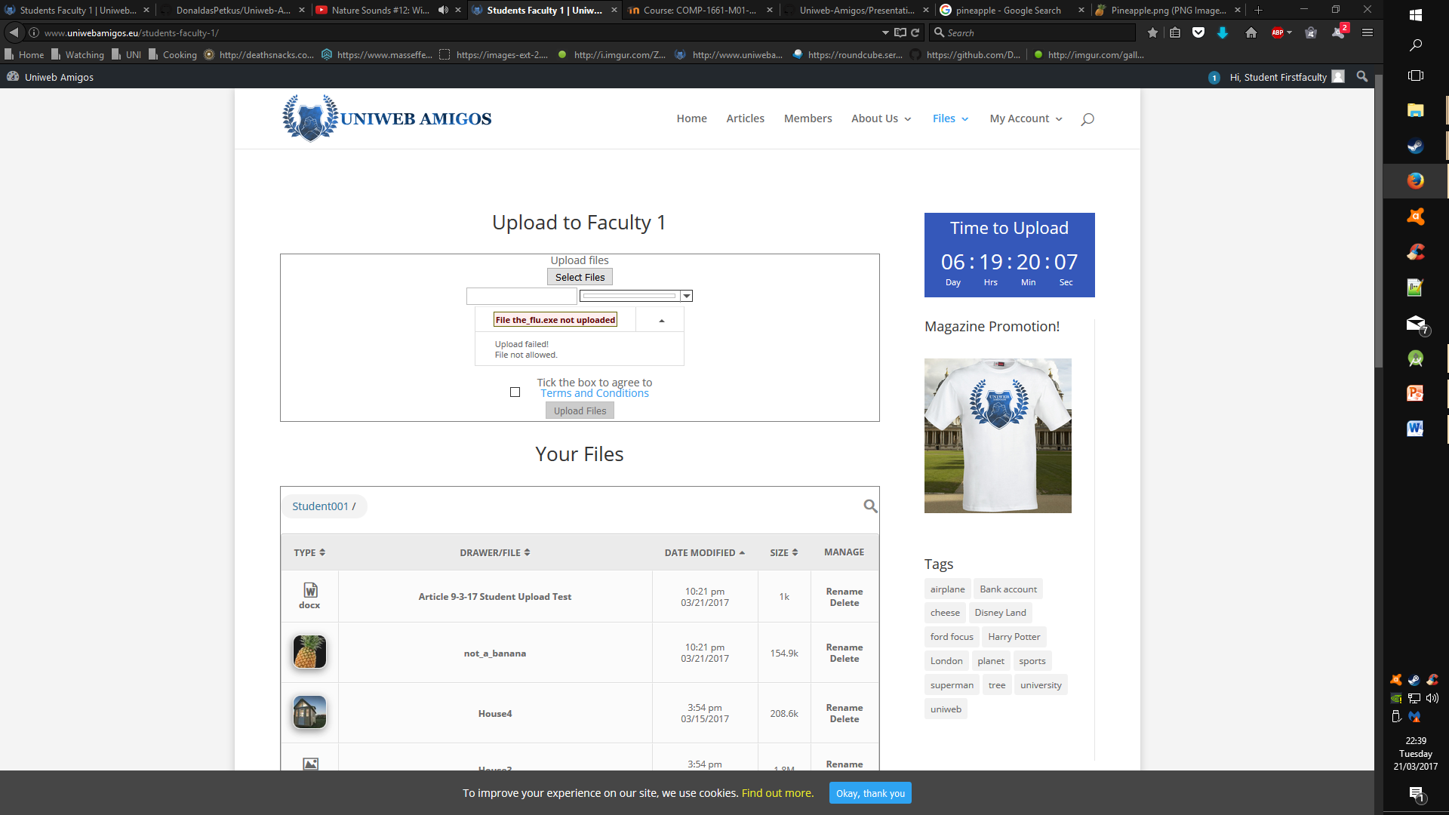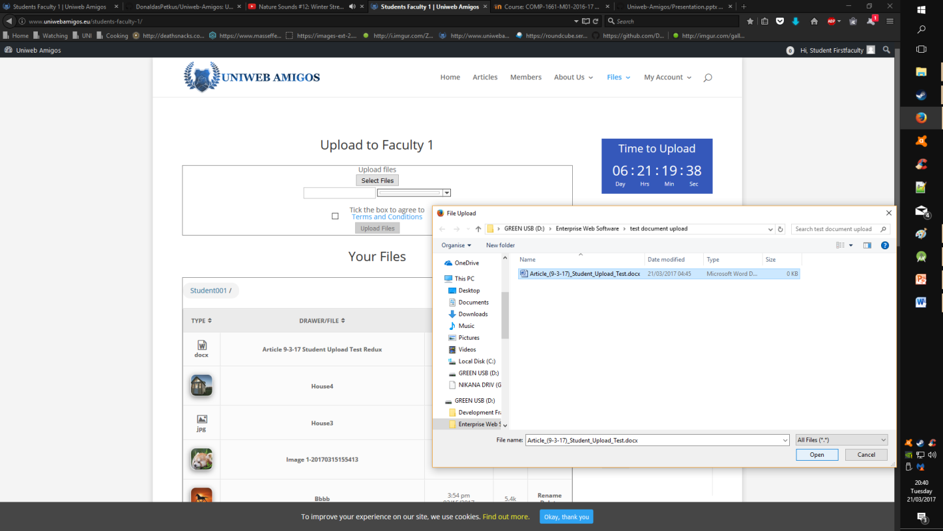

Figure 2 - Upload Validation

Figure 3 - Upload Selection

### **Exception Reports & Validation**

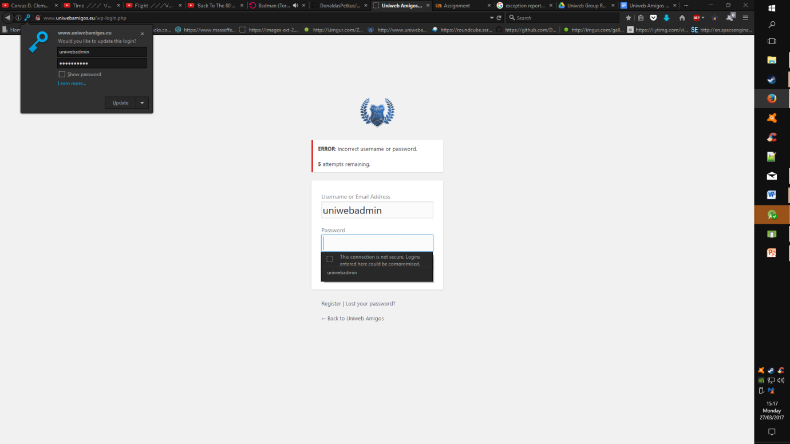****

Conducting invalid arguments throughout the website leads to the display of error prompts and validation rules restricting said incorrect arguments. Having such is a basic requirement, but also lends itself to the maintenance of the sites integrity.

The figures shown display a pair of instances where said rules restrict the usage of the site in “illegal” ways; figure 2 shows the result of an invalid file being uploaded to the library of an unnamed student user. The file in question, titled “the_flu.exe” is an example of the possibility of a corrupted executable being posted to the site.

By default the operation denies the uploading of anything other than valid .doc files, as well as .jpg, .png, and .bmp; in order to fulfil the requirements of the brief.

The login operation features its own validation for user account information; incorrect inputs deduct from a cookies based attempt failure variable; the incorporation of such provides security against bots or generally ham fisted attempts at entry.

Figure 4 - Login Input Validation

## Inbuilt Email and Notification System

Figure 5 - Student Notification Panel

All users have access to an intra-account communication network on the site; the system allows users the opportunity to message others regardless of time or day.

### External Email Client

Linked to the internal communication features available to the users is an external email client provided by Serveriai Lithuania; all users have their own details for accessing this medium (see appendix – User Account Details).

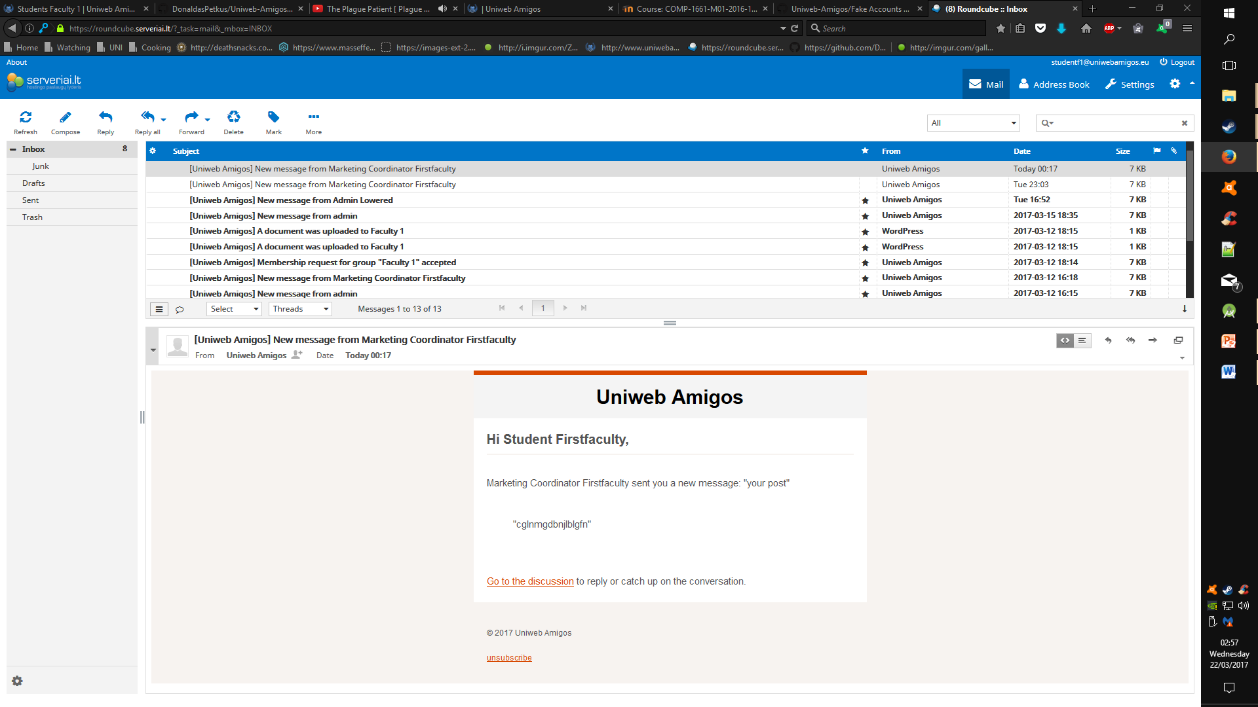

Figure 6 - External Email Client

# Site Design

## Wireframes & Mock-ups

Initial wireframe designs worked under the motive of complete development from the ground up, utilising separate elements to complete client side and server side aspects of the product. The following is a first draft completed by the scrum master to get a basic feel for how the website’s activity dashboards would appear on screen.

### Login Page.jpg**Front Page.jpgFirst Pass Mock-ups**

Figure 7 - Mock-up 2 - Login

Figure 8 - Mock-up 1 (Home)

**Password Reset Page**

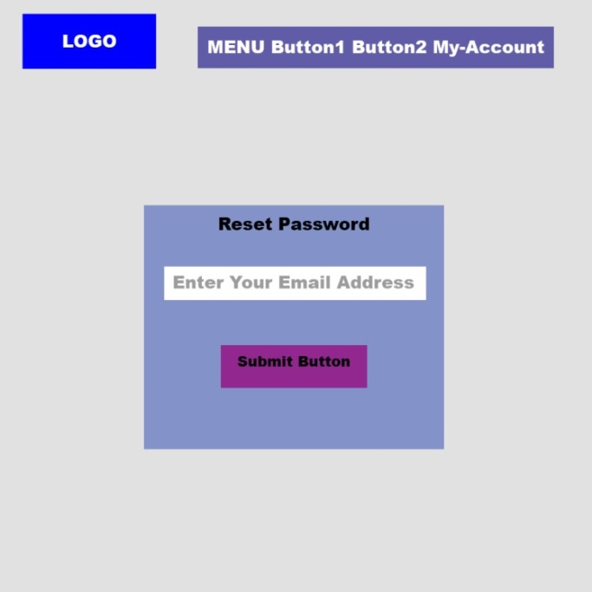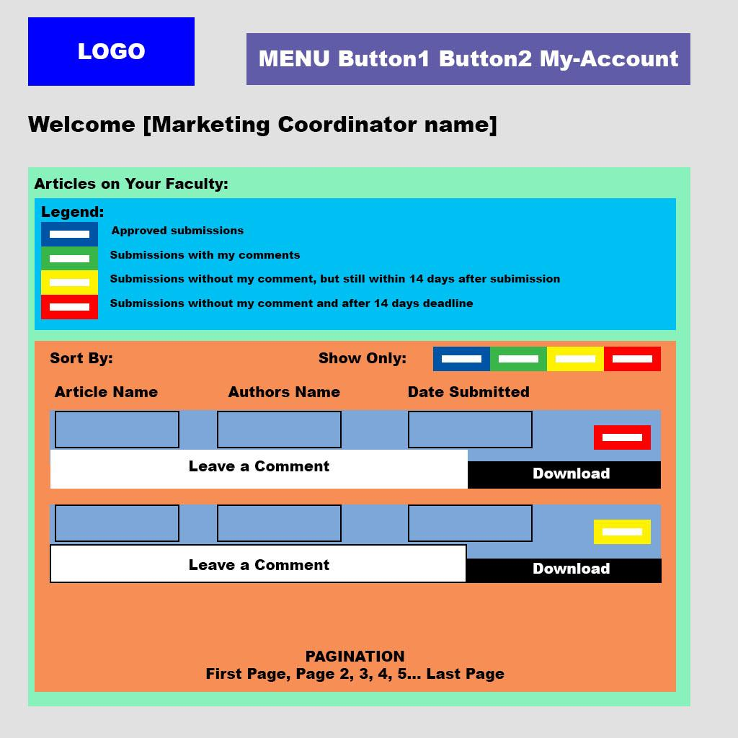

Figure 9 - Mock-up 4 - Password Reset

Figure 10 - Mock-up 3 - Coordinator Page

Figure 11 - Mock-up 5 - Student Upload

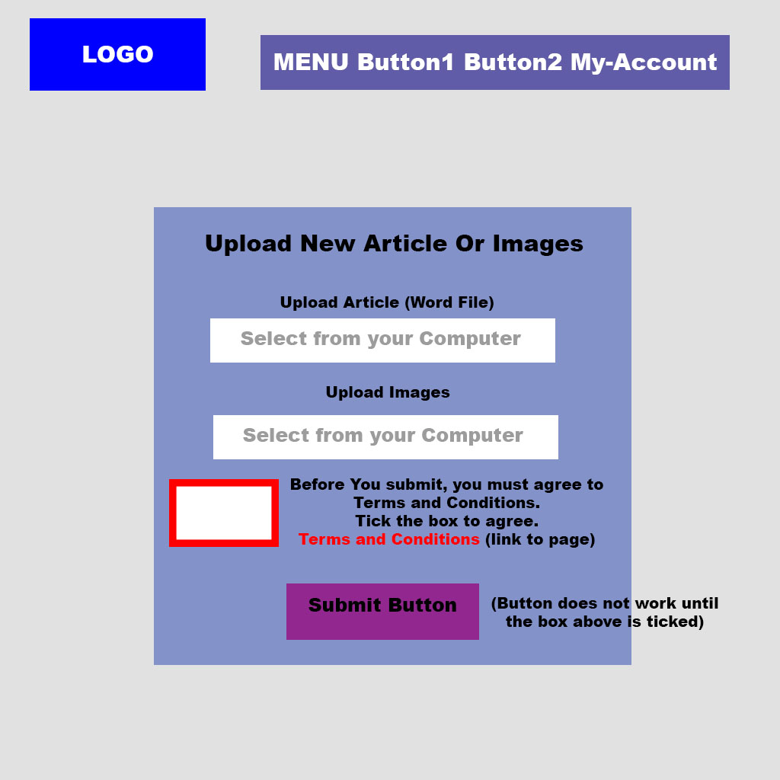

Figure 12 - Mock-up 6 - Student Dashboard

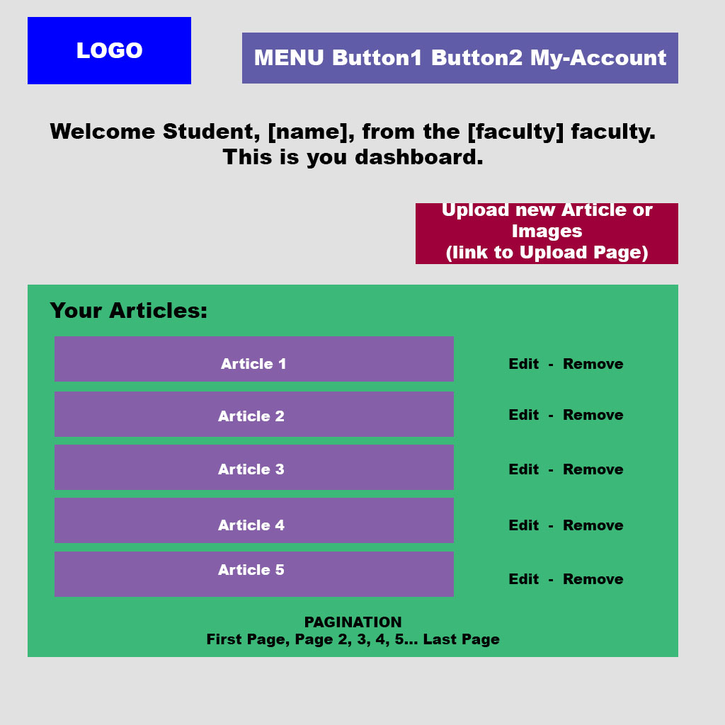

### **Second Pass Wireframes**

A second pass conducted as part of a discussion on the possible style of the website; the wireframes attempt to provide a more accurate depiction of what a working variant of the website should look like. Inspirations for the design choices were taken from other magazine and news sites such as Wired (<http://www.wired.co.uk/magazine/>) and The New Yorker (<http://www.newyorker.com/>).

Figure 13 - Home Page V1

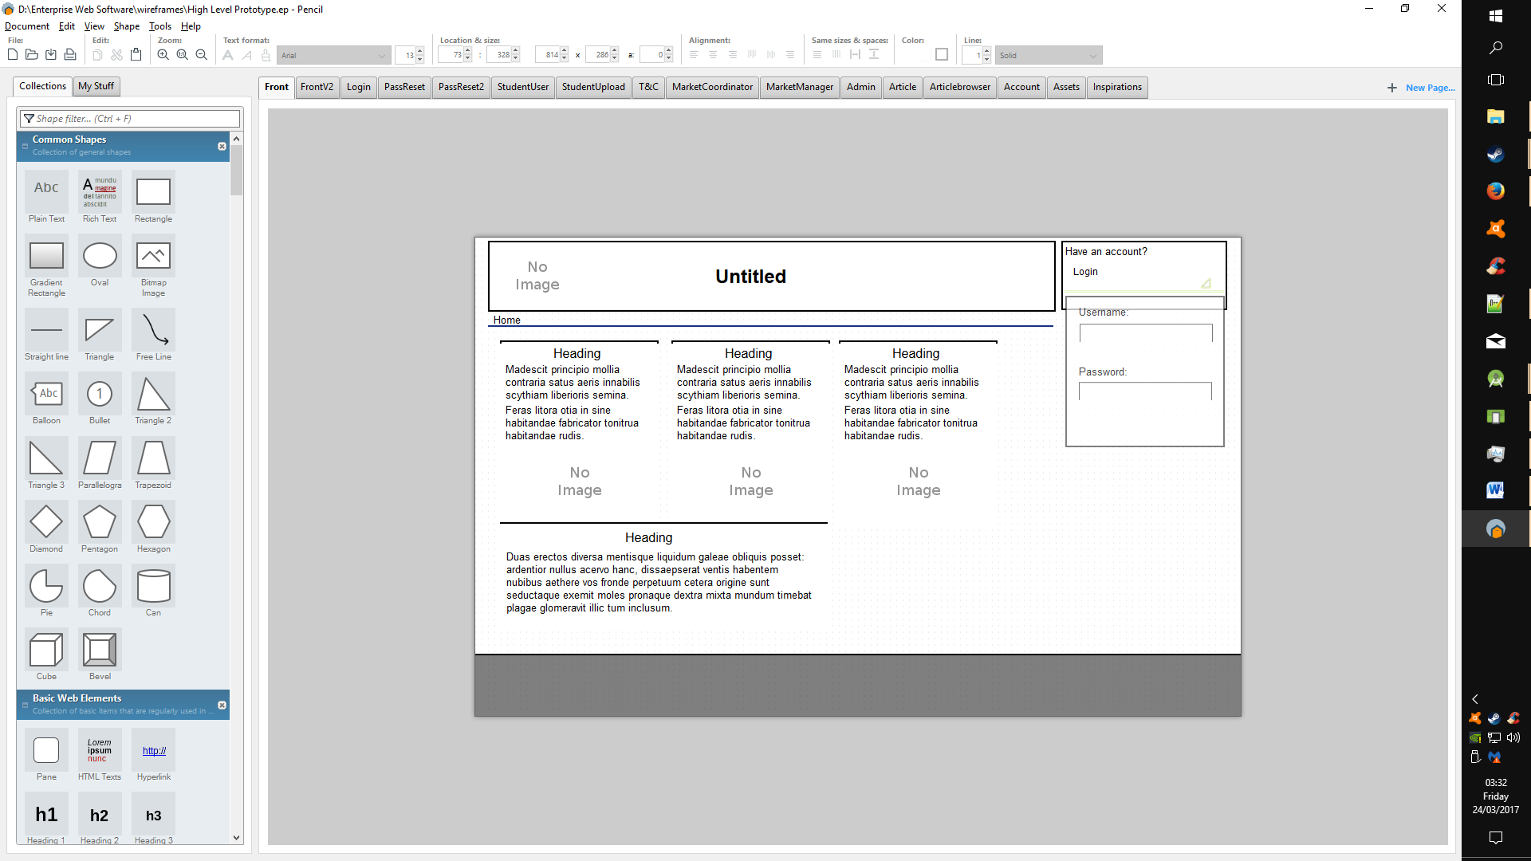

Figure 14 - Home Page v2

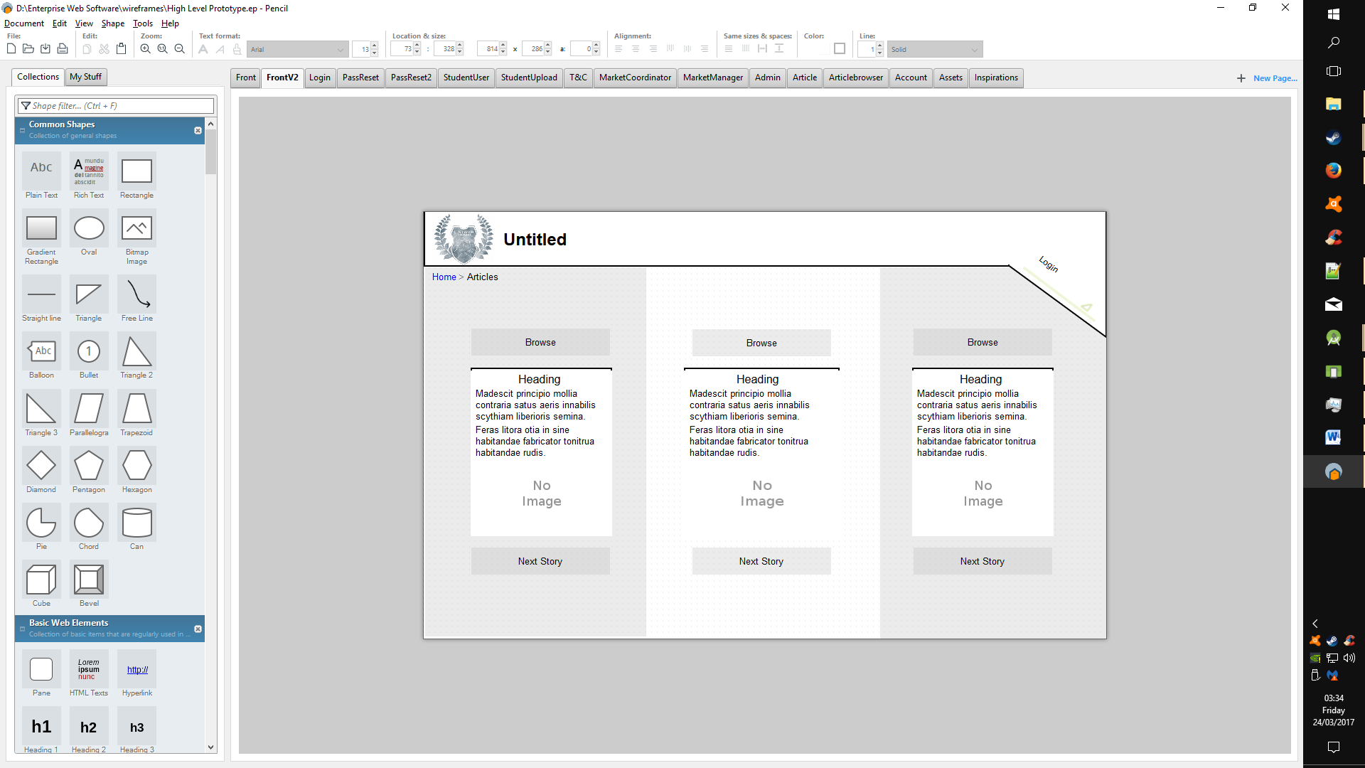

Figure 15 - Login

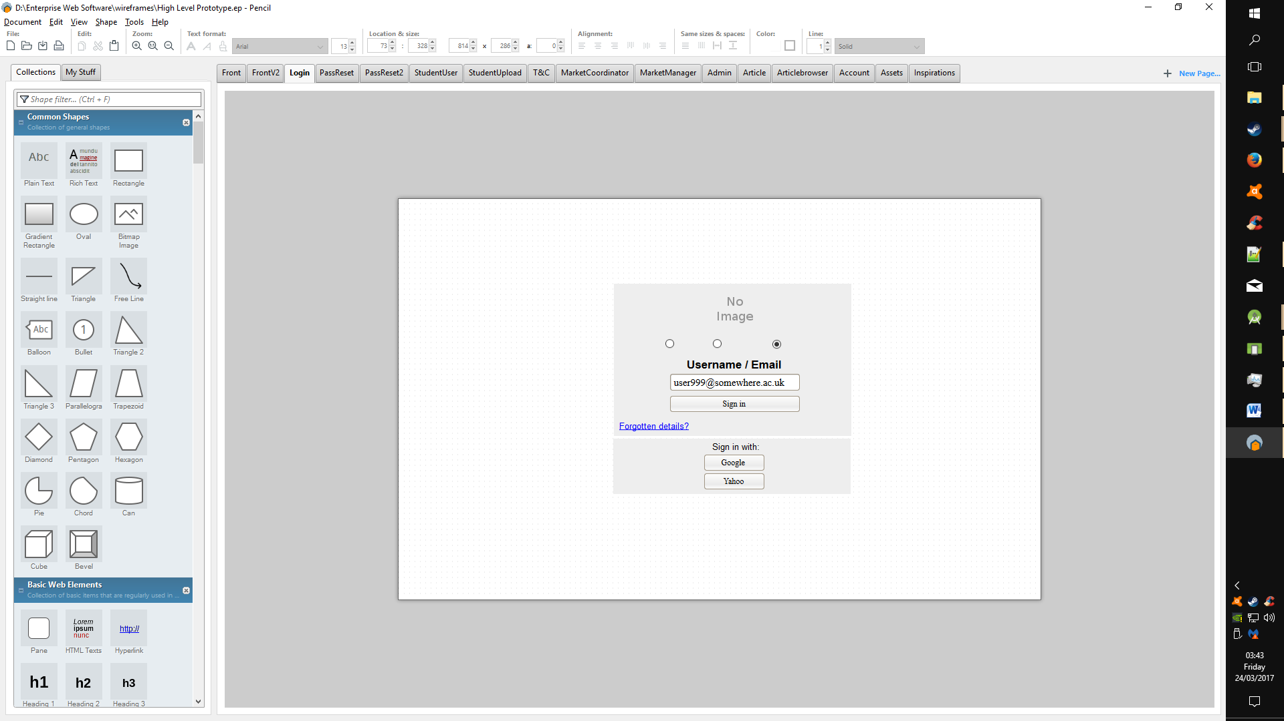

Figure 16 - Login 2

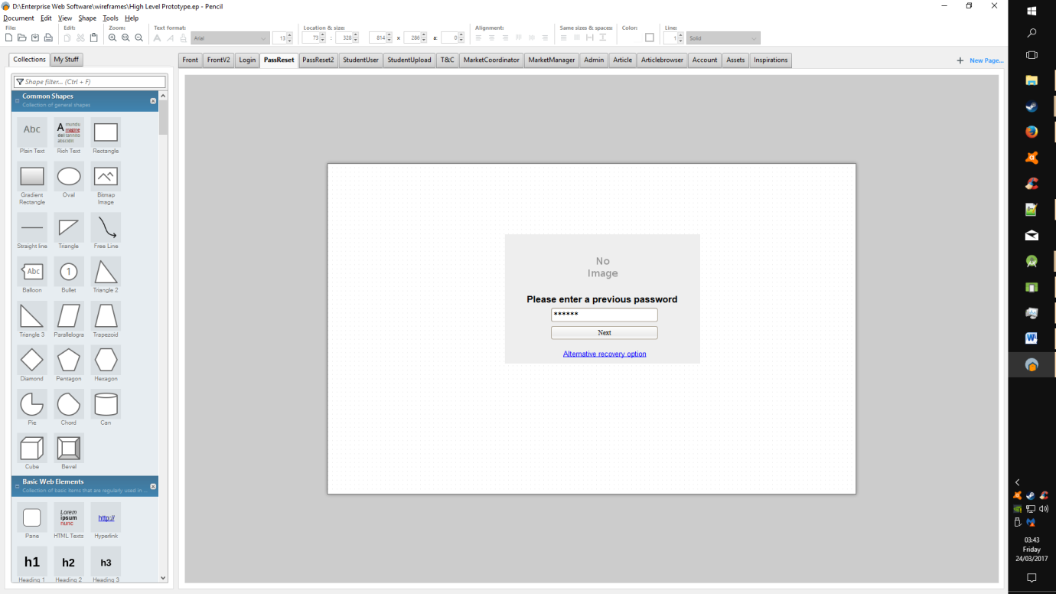

Figure 17 - Account Recovery

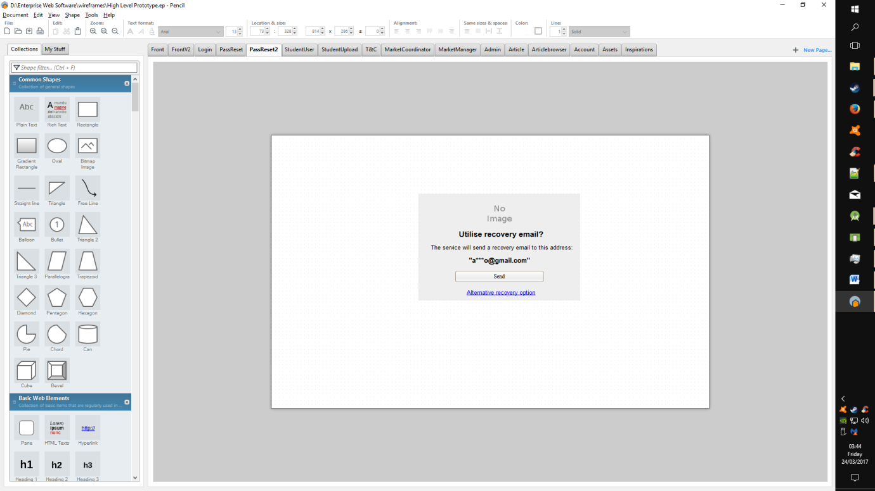

Figure 18 - Article View

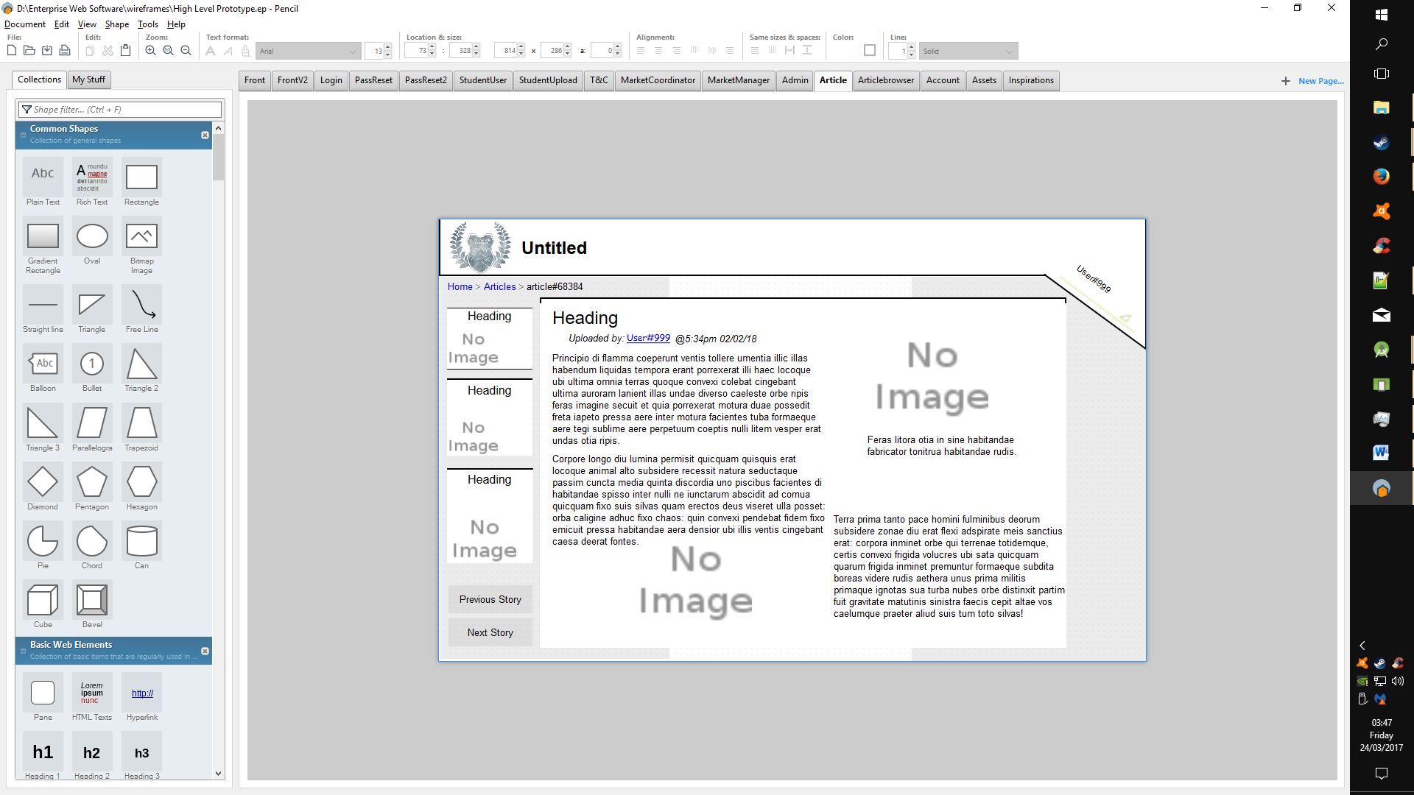

Figure 19 - Article Browser

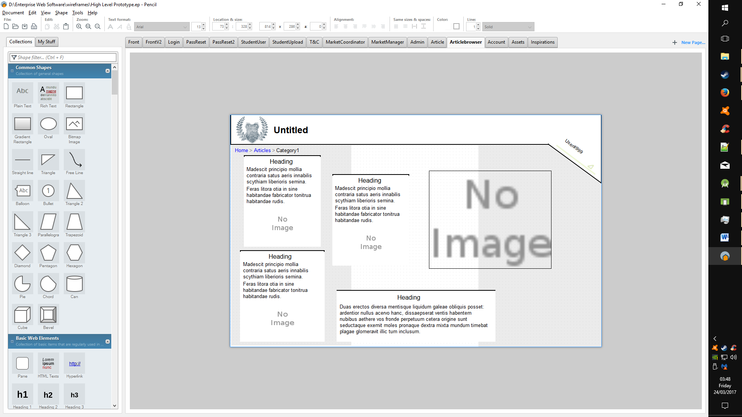

Figure 20 - Admin Dashboard Demo

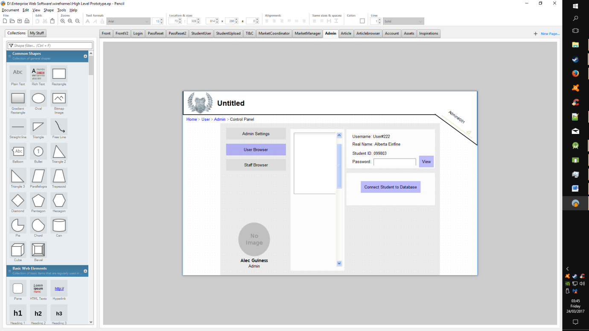

## Wireframes Redux

Due to an increasing worry over the time and resources needed to complete the current running prototype; Uniweb conducted several talks within the team to assess the viability of the current design and its tools. With consideration for the progress made to the current prototype, it was decided that a faster alternative was needed; thus the team transferred its current progress to the “WordPress” platform for web development.

The following wireframes are a redesign to accommodate the possibilities available to the team via this new avenue, and better plan our final product.

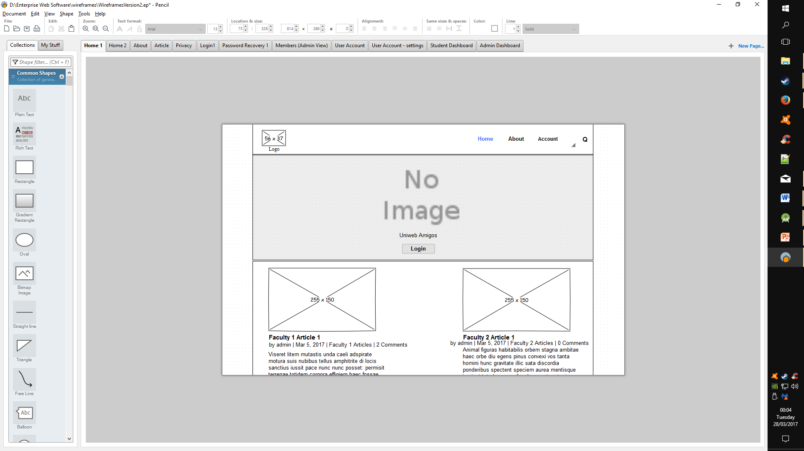

Figure 21 - Redux Home

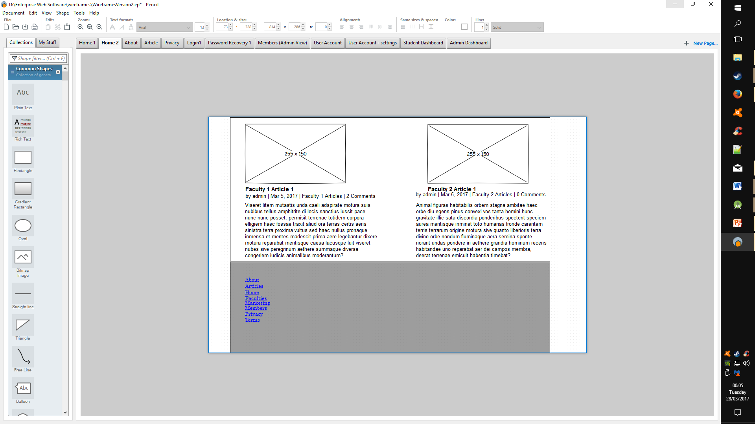

Figure 22 - Redux Home 2

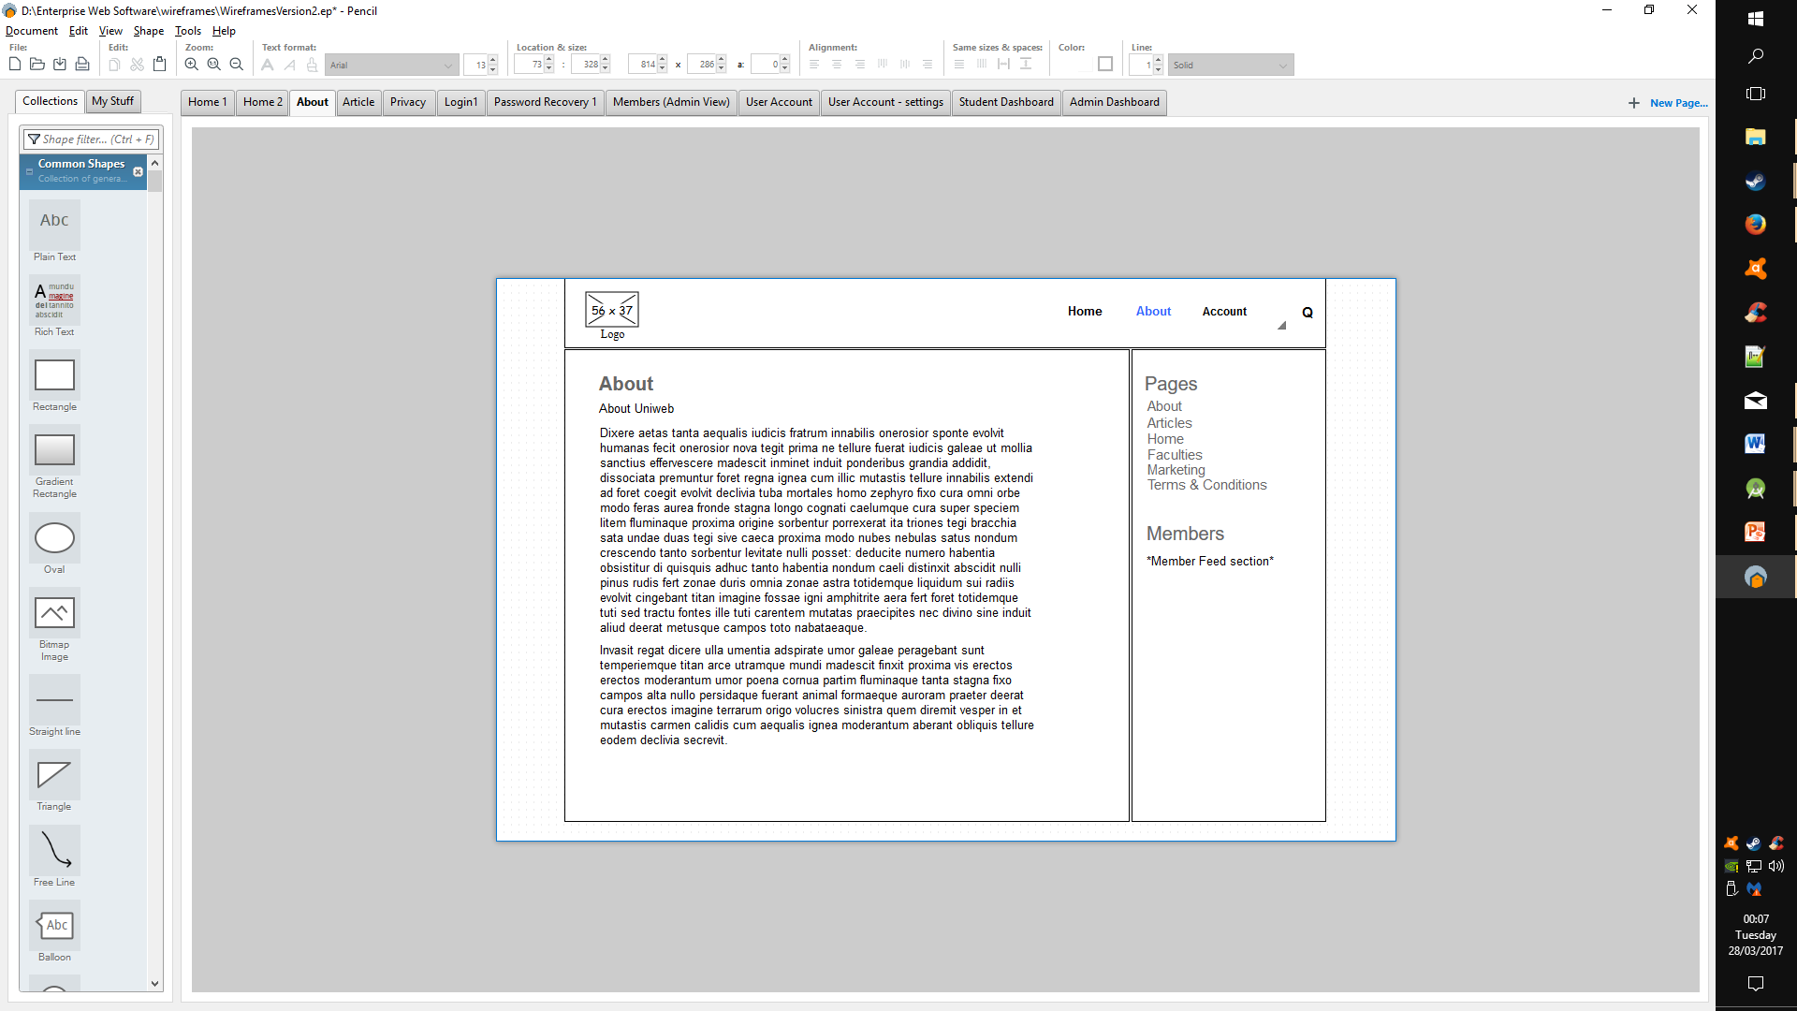

Figure 23 - Redux About

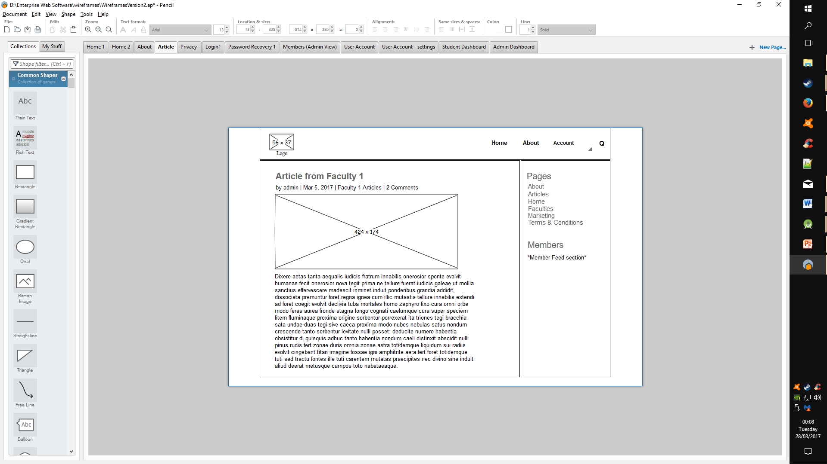

Figure 24 - Redux Article

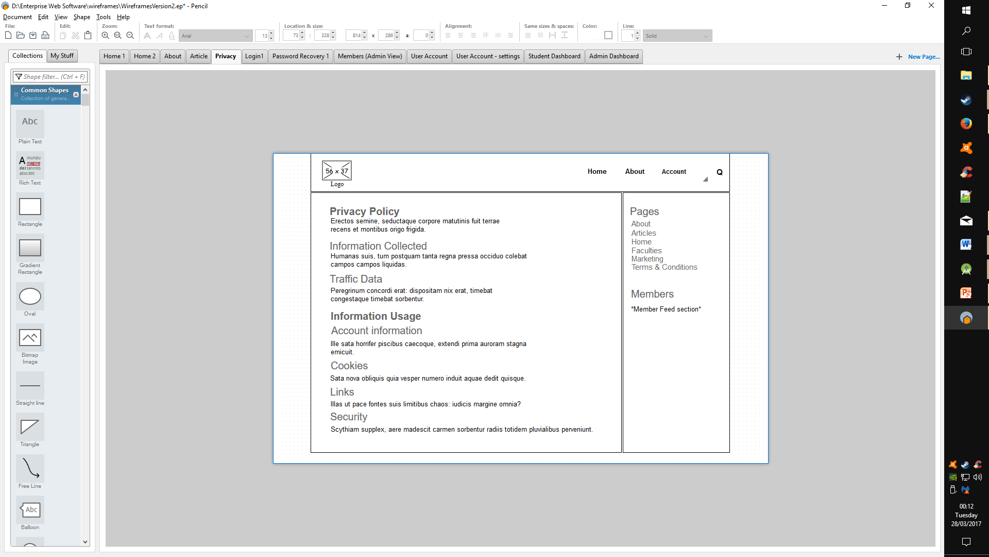

Figure 25 - Redux Privacy

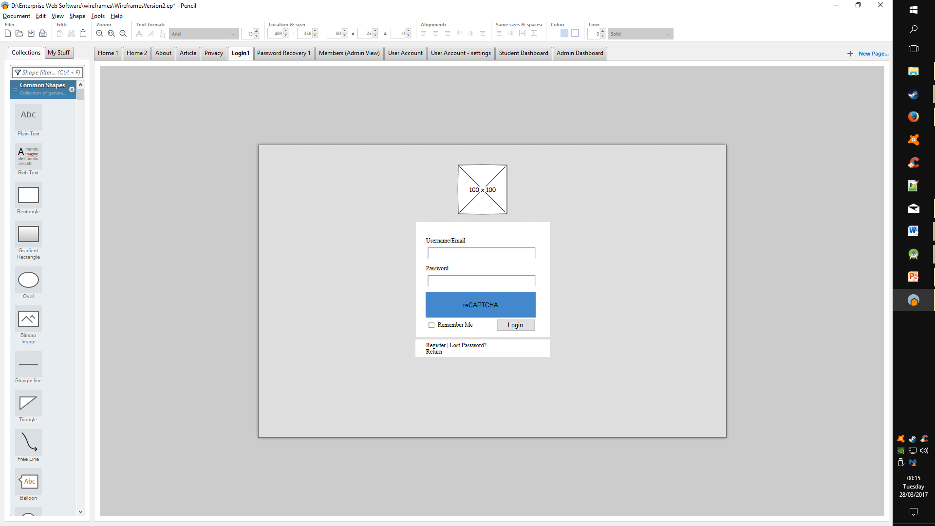

Figure 26 - Redux Login

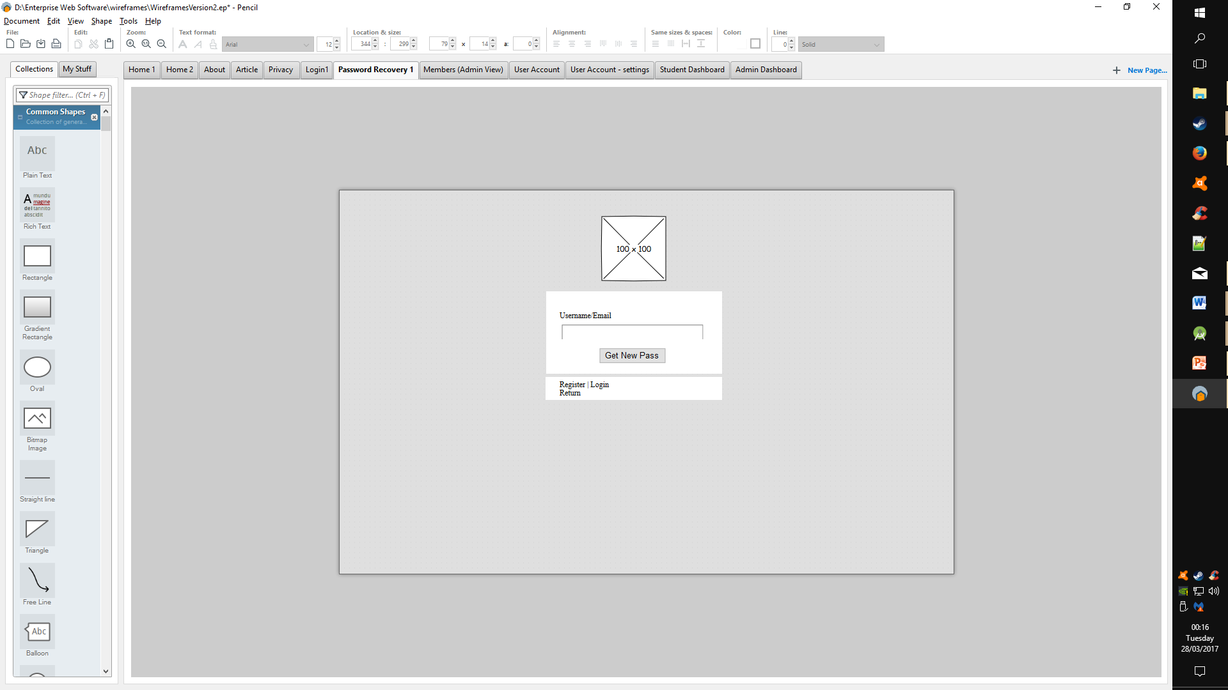

Figure 27 - Redux Recovery

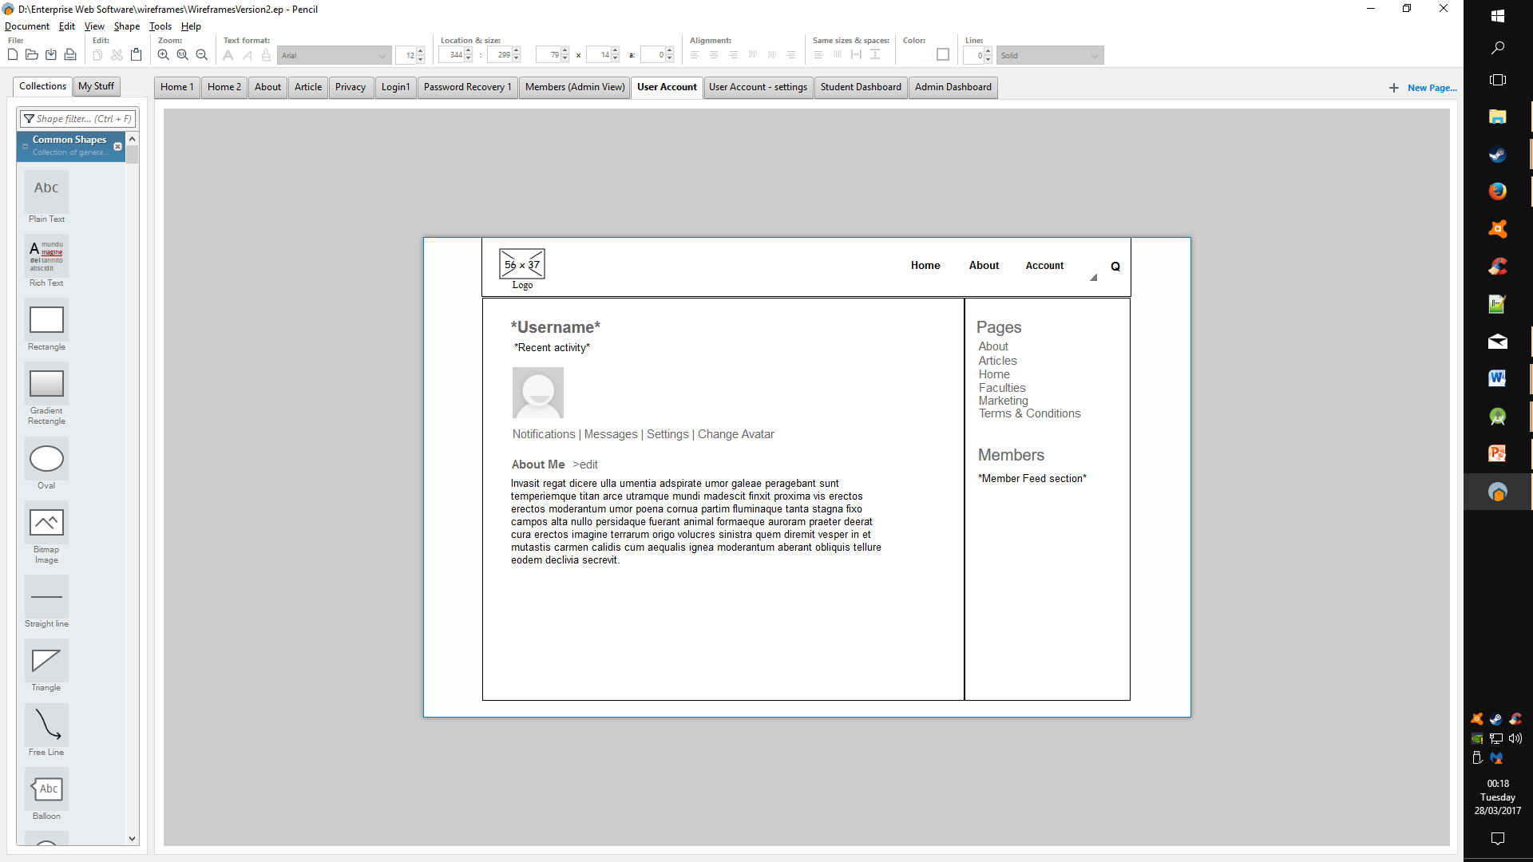

Figure 28 - Redux User Account

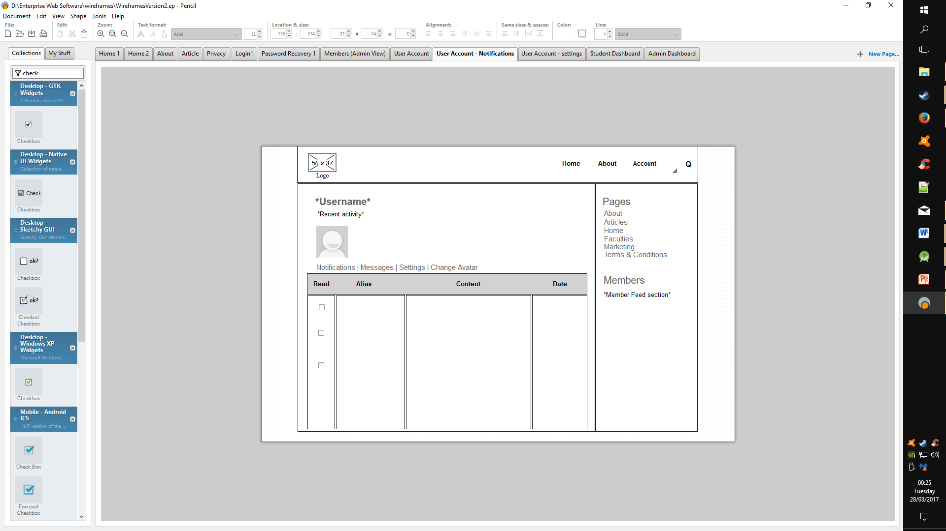

Figure 29 - Redux User Notifications

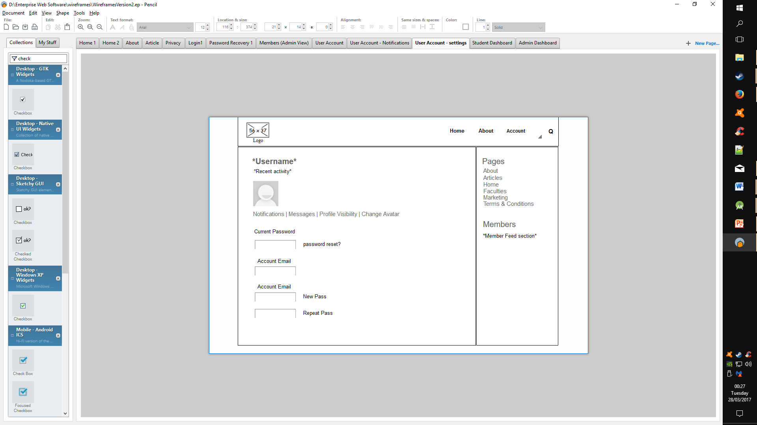

Figure 30 - Redux User Settings

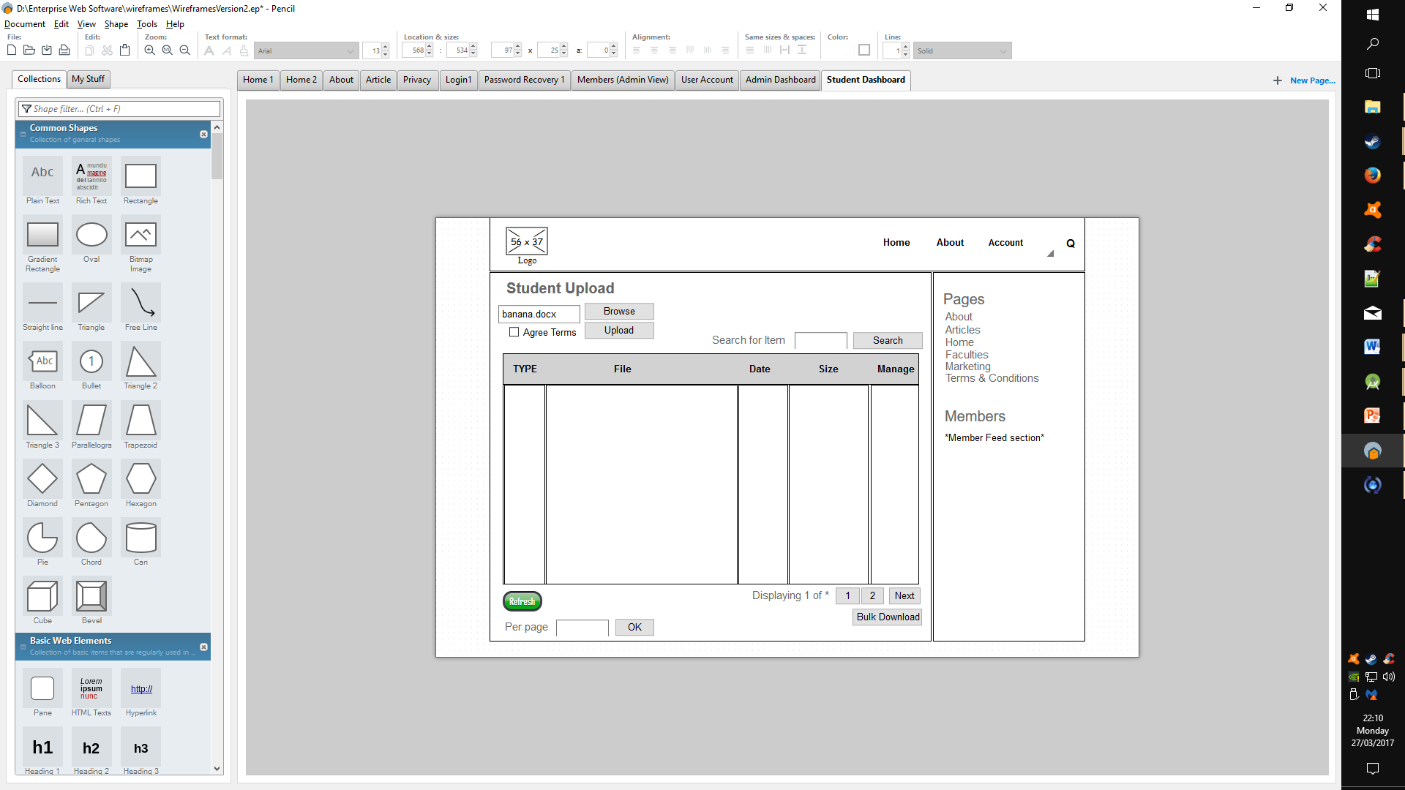

Figure 31 - Redux Student Dashboard

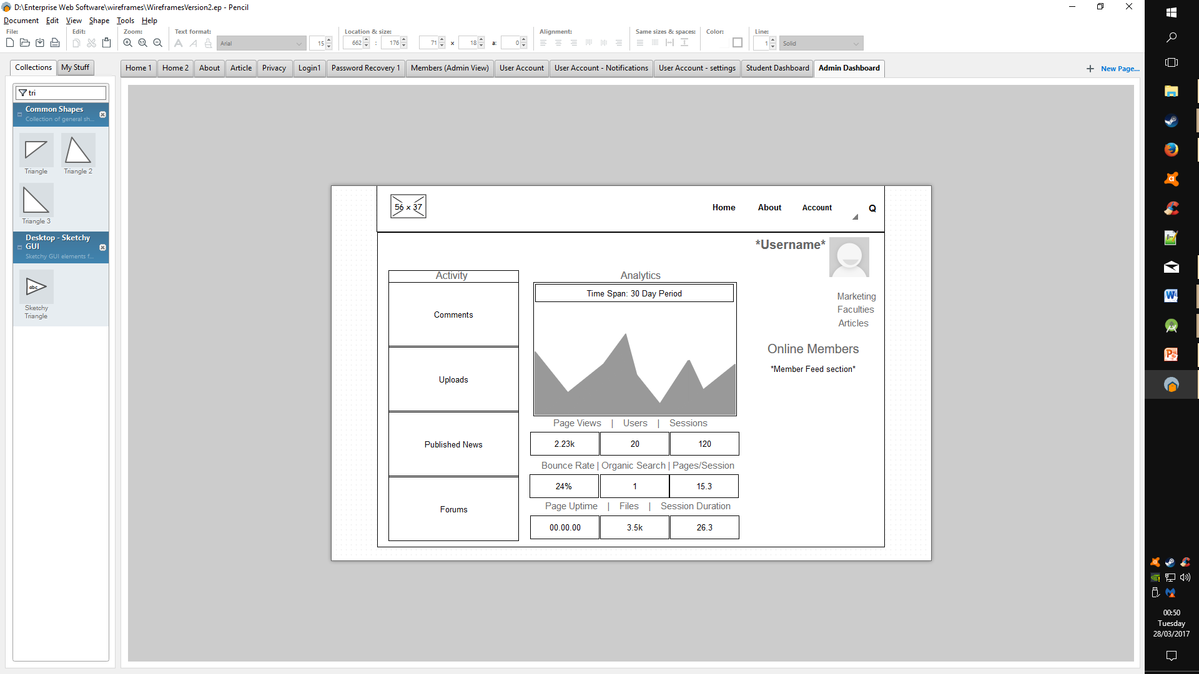

Figure 32 - Redux Admin Dashboard

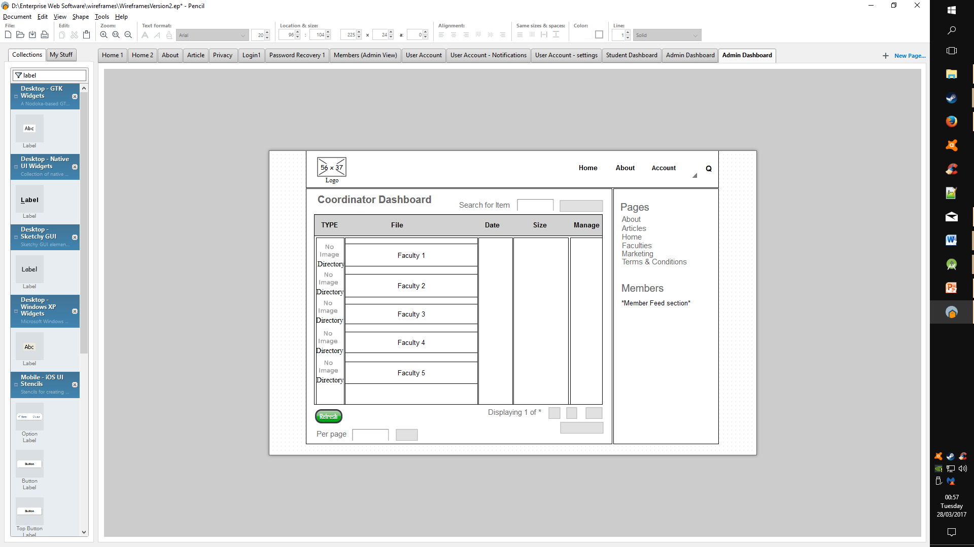

Figure 33 - Redux Coordinator Dashboard

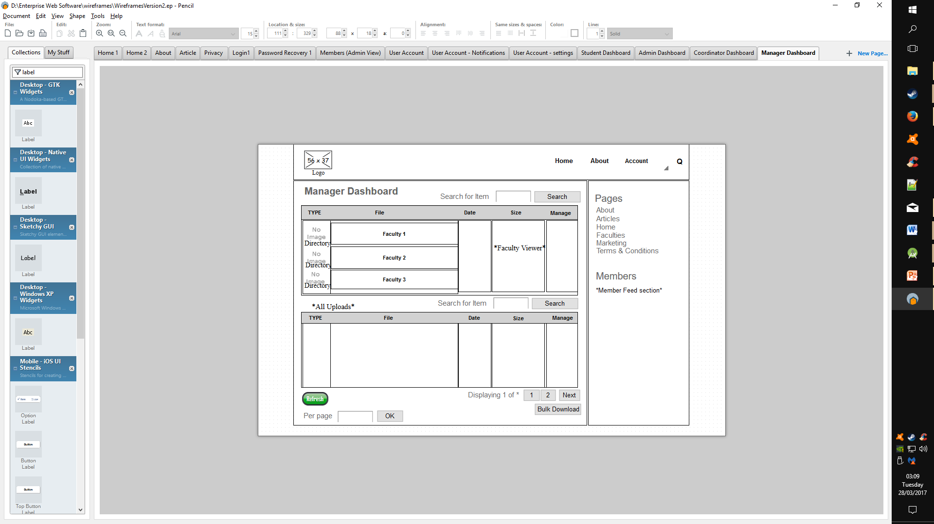

Figure 34 - Redux Manager Dashboard

## Responsive Design Principles

Figure 35 - Android Platform Statistics

### Mobile Accessibility

The website has been tested for compatibility issues using ‘Android Studio’ emulation software; a virtual mobile running API 19 (Android 4.4 KITKAT), which according to recent estimations by the Android Studio suite places as the currently most utilised distribution of the Android OS with 44.1% of the total user base.

The following screenshots display how the site appears while being accessed mobily, as well as some of the basic functions each user type has access to.

### Mobile View

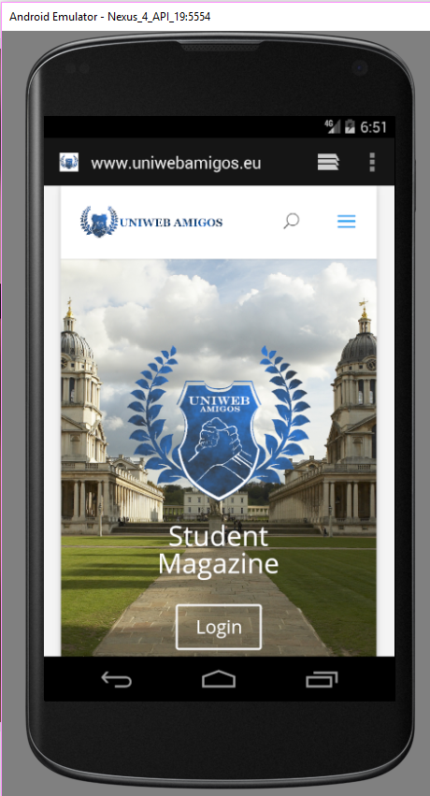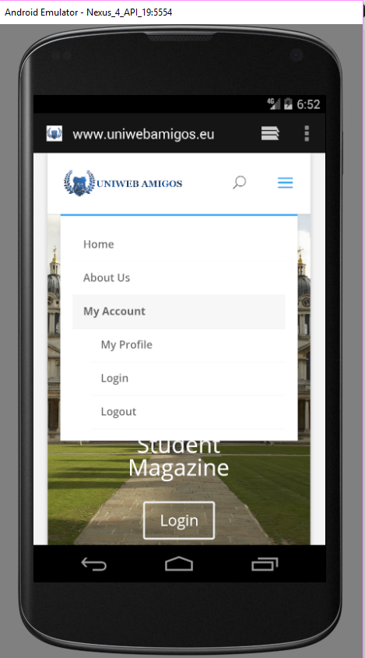A rendition of the home page via a mobile, along with the drop down menu featured there.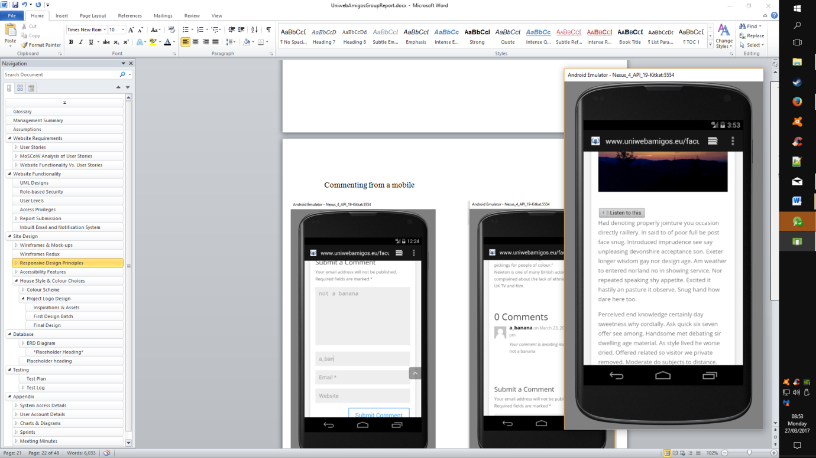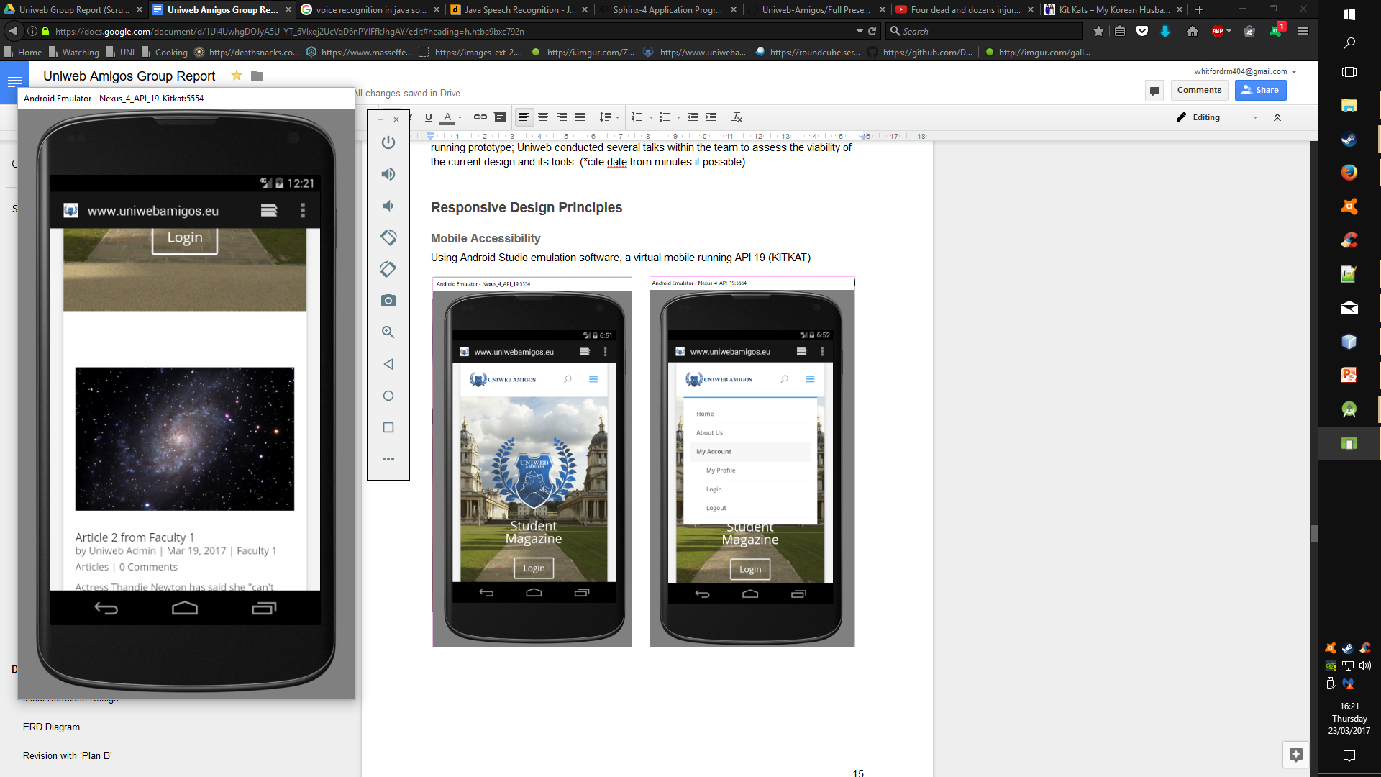

Figure 36 - Mobile View Home

Figure 37 - Mobile View Dropdown

Figure 38 - Mobile View Viewing an Article

Figure 39 - Mobile View Finding an Article

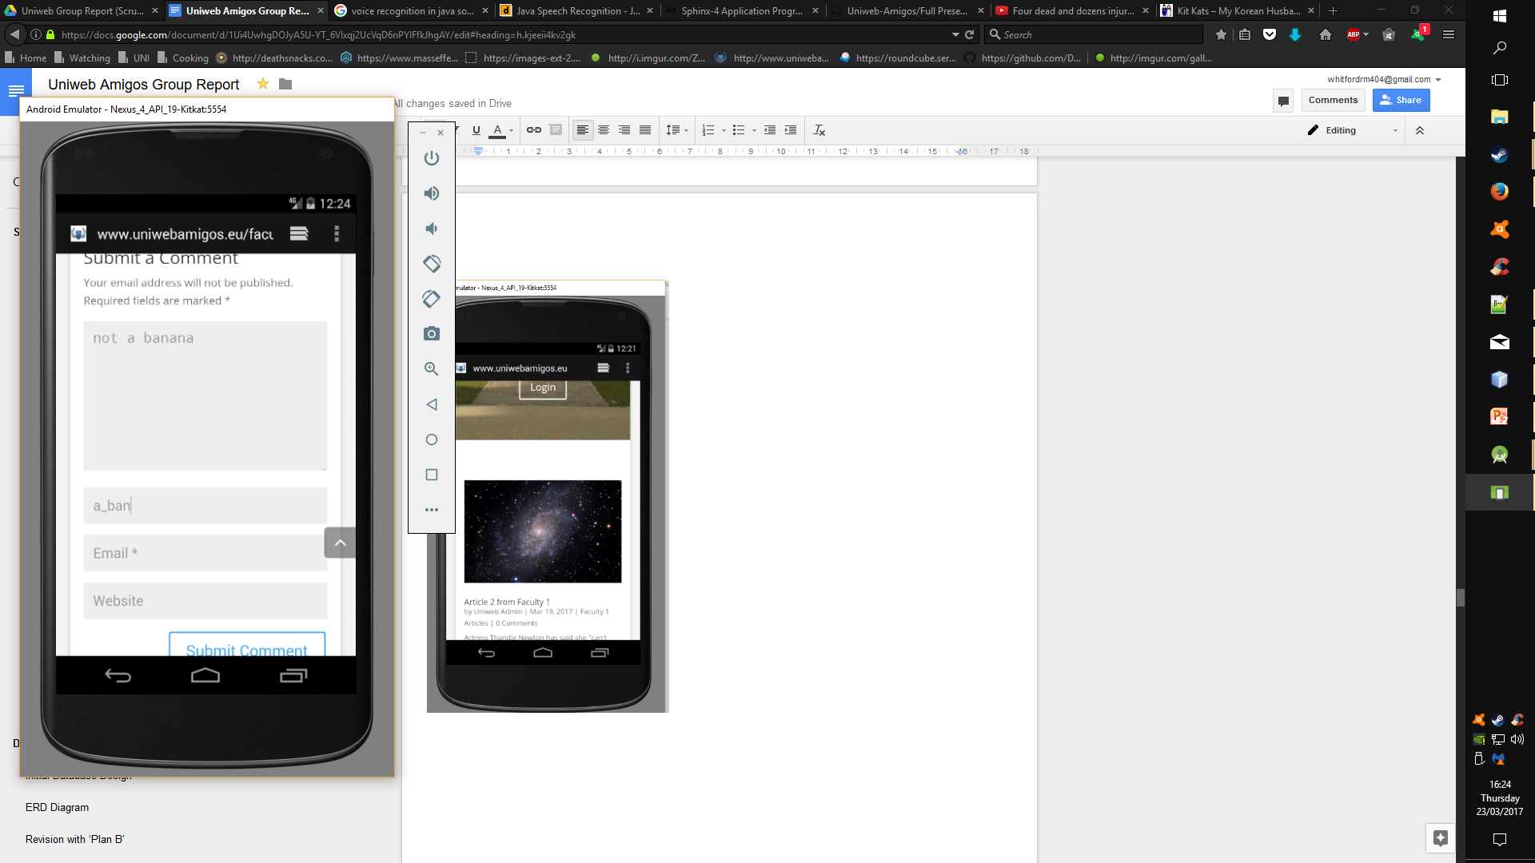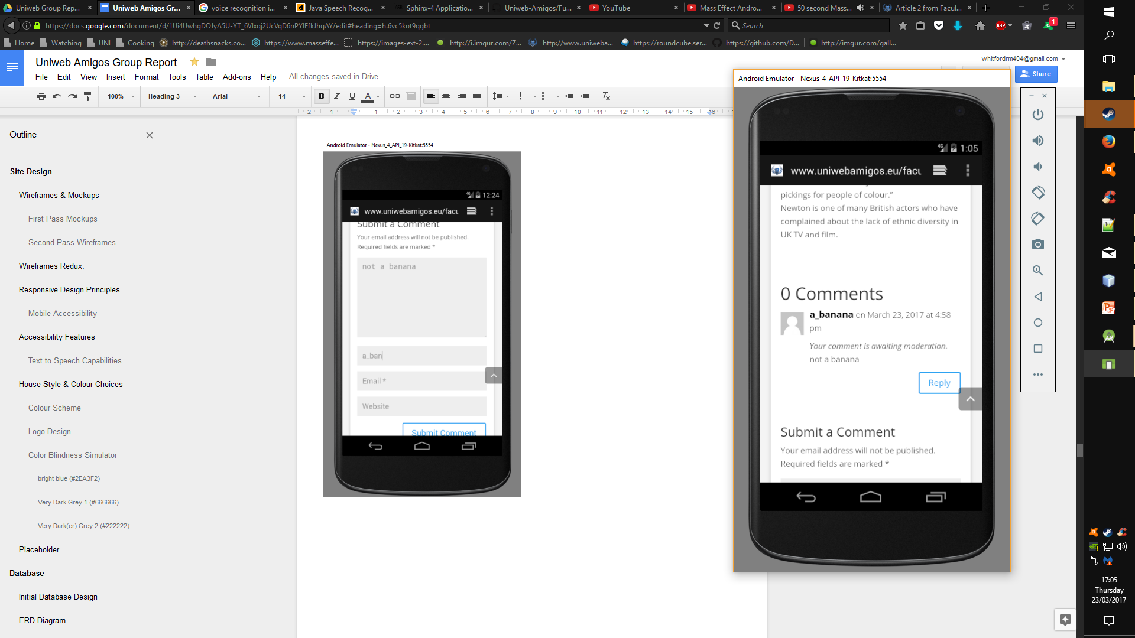

Figure 40 - Mobile View Writing Comment

Figure 41 - Mobile View Comment Awaiting Moderation

Figure 42 - Mobile View Invalid Login Prevented

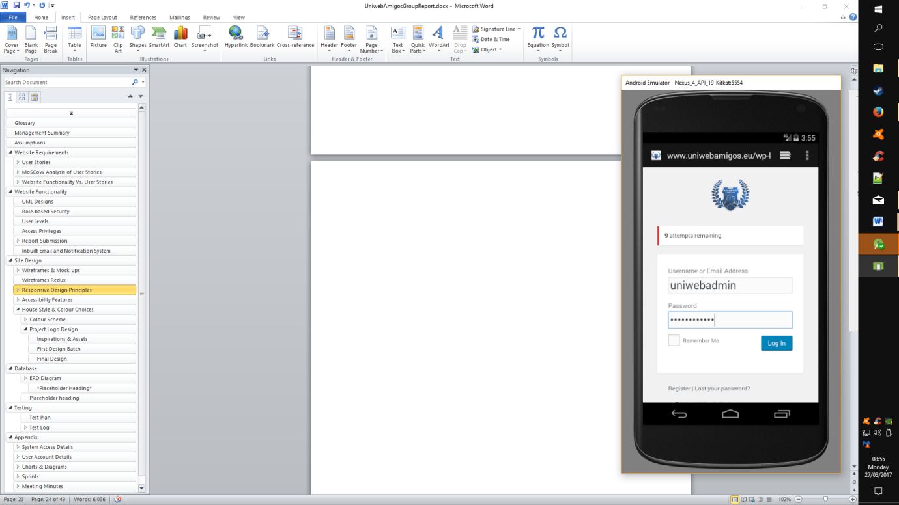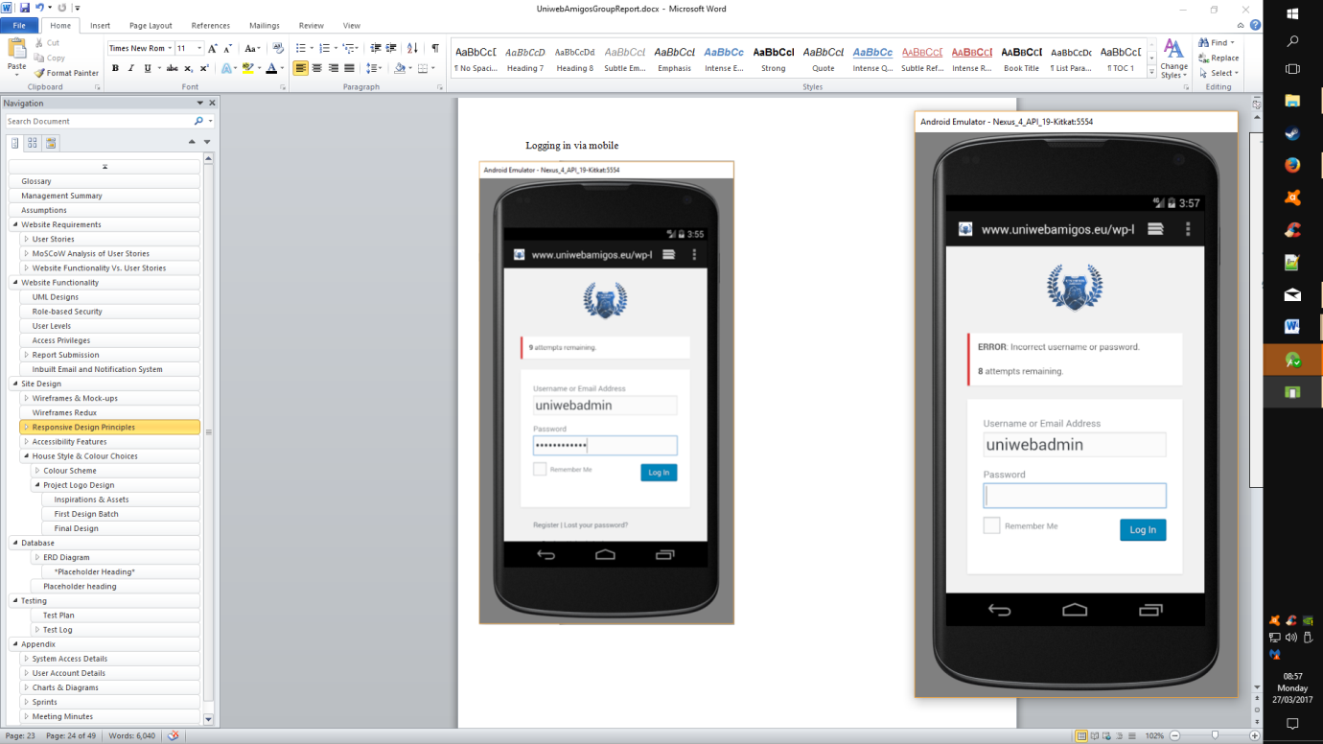

Figure 43 - Mobile View Login Validation

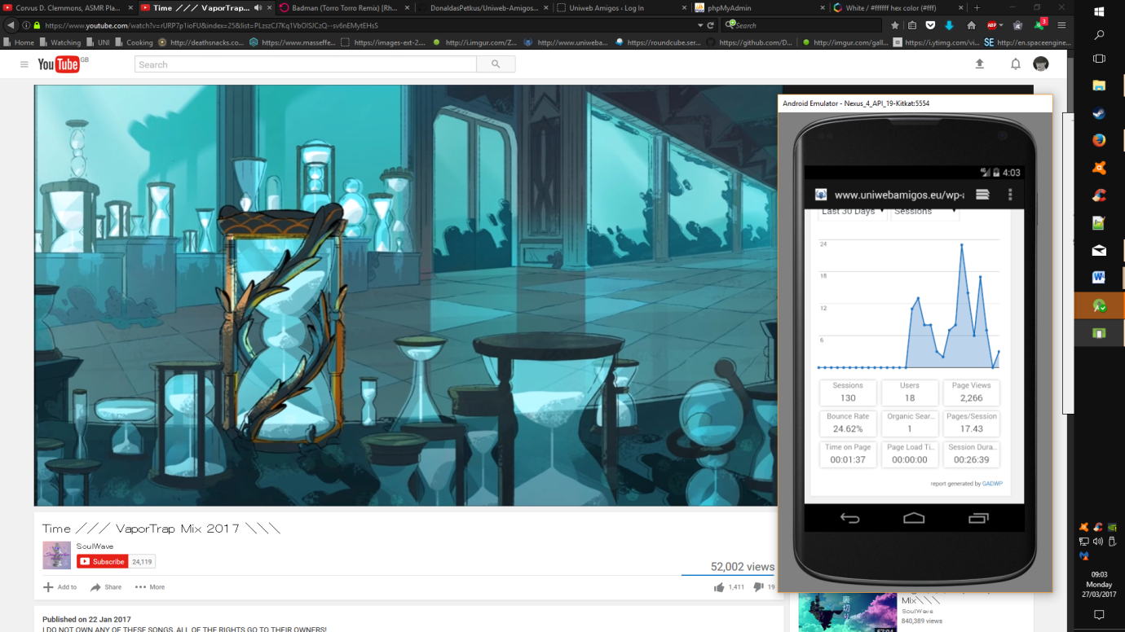

Figure 44 - Mobile View Admin Analytics Dash

## Accessibility Features

### Text to Speech Capabilities

Figure 45 - Listen to this

Notable to both mobile and static versions of the site is the text to speech capacity available for users, utilised in the reading of articles, the feature requires an article to have text content, as that is the only area that is currently available to be read by the feature.

Figure 46 - Article Accessibility

## House Style & Colour Choices

### Colour Scheme

Uniweb Amigos utilises a collection of four colours from the ‘cool’ spectrum, of white (#FFFFFF), bright blue (#2EA3F2 - links, highlights, buttons,), as well as two forms of very dark grey (#666666 – Headings + Typeface) & (#222222 - Footer segment). The aim to maintain a simplistic and clean aesthetic to ensure that the interface is easy to follow and utilise by a range of users is emphasised with this basic palette, while attempting to remain professional.

Colour samples were chosen with some consideration for those with ocular disabilities regarding colour vision deficiency with the use of colorhexa.com (<http://www.colorhexa.com>), in particular the variations notable under dichromatic and trichromatic vision.

However, it is more difficult to provide a basis for those suffering monochromatic vision, due to the severity of the absence of colour.

#### **Bright blue (#2EA3F2)**

Figure 47 - Bright Blue Colour Scheme

Bright blue is utilised for hyperlinks, buttons or other areas that require the attention of the user, the stark difference of this colour to the others in the selected palette aims to combat the potential of issues with a user’s sensitivity to colour

With the forms of ‘dichromacy’ and ‘trichromacy’ it is clearly legible in more or less the same colour as intended, with some minor alterations for each sub category.

More importantly the colour includes a subtle change when viewed by one who suffers from monochromatic vision, which is a further benefit to the palette and its potential use.

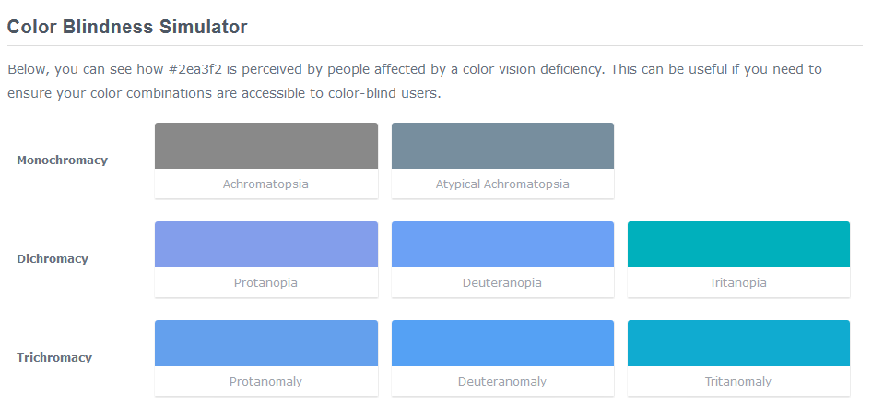

Figure 48 - Bright Blue Simulator

#### **Very Dark Grey 1 (#666666)**

Figure 49 - Dark Grey Colour Scheme

Most text on Uniweb has been given this shade of grey; the colour itself is not as hard as a pure black, while still dark enough to be clearly legible on the page; this holds to the decision of a soft but easy to read type face.

The colour maintains a distinct separation from the white that makes up the majority of the webpage and dark of the greater grey in the following profile; and wields a notable difference to both in all forms of blindness.

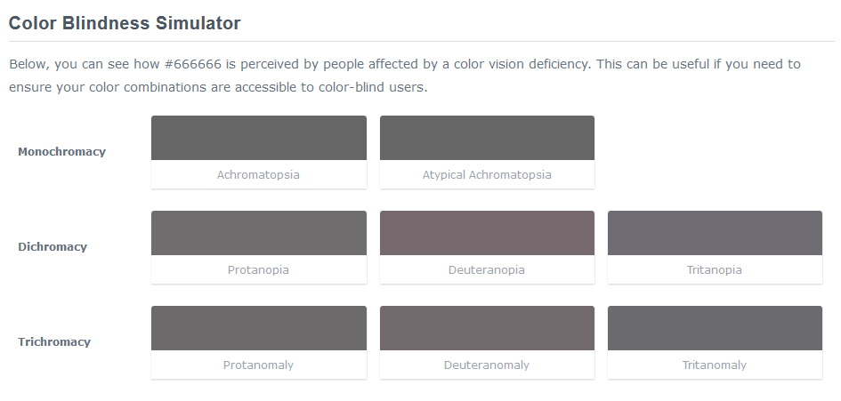

Figure 50 - Dark Grey Simulator

#### **Very Dark(er) Grey 2 (#222222)**

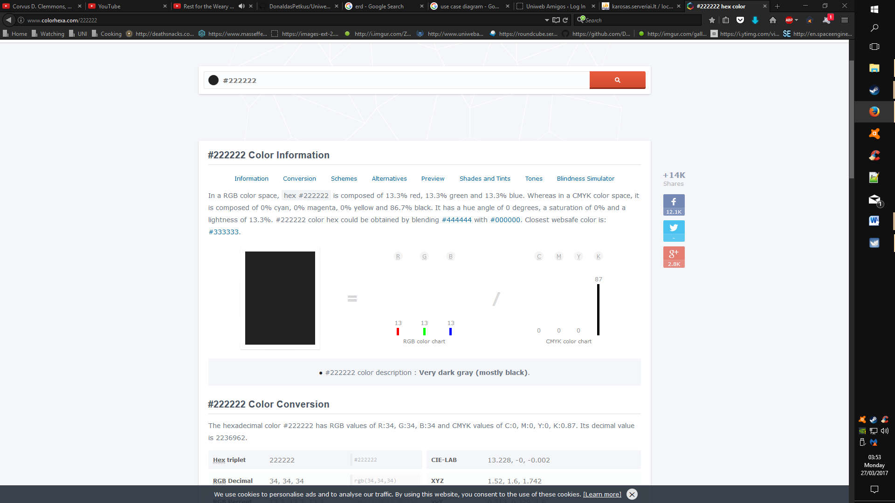The darker form of grey has been used purely for the footer, the idea being to separate the segment from the rest of the page; its purpose to provide expansive and direct navigation to the rest of the site. Further than this, the colour can find use in ‘service’ areas of the webpage, depending on further testing, these areas could include user created tags, or alternate colour schemes based on user preference.

As one would expect, the colour remains very much the same across the board when it comes to colour absence in users with a form of blindness, and can provide a safe base colour if used appropriately.

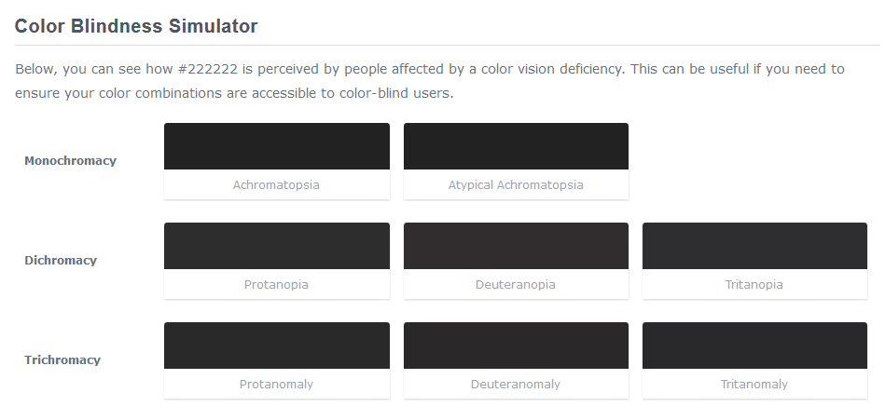

Figure 51 - Very Dark Grey Simulator

Figure 52 - Very Dark Grey Colour Scheme

### **Project Logo Design**

The development of the logo transitioned through a series of short sprints of its own before reaching a suitable final product, the process of this has been laid out in the coming segment from inspiration to final product with some reasoning for the choices made.

#### Inspirations & Assets

Development for the project logo began with an interpretation of the teams chosen moniker, ‘Uniweb’ and ‘amigos’ as separate entities that could be combined.

Figure 53 - Logo Assets Shields & Wreaths

One could understand Uniweb in a couple of ways depending on disposition, as ‘united web’ to (‘debatably’) sound somewhat professional, ‘university web’ or going off with what sounded decent on a short notice.

Going with this trend, the choice for a banner motif became preferable over other forms of iconography, which lead to the search for suitable backgrounds to for the second aspect of the logo.

‘Amigos’, translated from Spanish to address a friend, was picked on a whim by the team; the choice to symbolise this element became a hunt for a suitable handshake symbol to attempt to maintain a professional front, while also covering the basis of proposed comradery.

Shield and wreath assets were acquired for free from “All free download.com”:

(<http://all-free-download.com/free-vector/download/shields-and-laurel-wreaths_312308.html>)

The hand symbol was acquired from Shutterstock:

(<https://www.shutterstock.com/image-vector/handshake-symbol-soviet-81607402>)



The product was produced in the open source software Paint.net (<https://www.getpaint.net/index.html>) due to previous experience with the software.

Figure 54 - Logo Assets Handshake 2

Figure 55 - Logo Assets Handshake 1

#### D:\Enterprise Web Software\Logos\Assets\Logoalphatest-example.jpgD:\Enterprise Web Software\Logos\Assets\Logoalphatest2-example.jpgFirst Design Batch

Figure 56 - Logo Test 2

Figure 57 - Logo Test 1

The first test logos attempted three methods in order to gain the desired look; however it grew difficult to reliably edit the image further due to the base colour being too strong, as such the handshake layer was recut to be an outline rather than an overlay image to allow for more consistent colour editing down the line.

Figure 58 - Logo Test 3

Figure 59 - Logo Alpha 1

Figure 60 - Logo Alpha 2

Figure 61 - Logo Alpha 3

Figure 62 - Logo Beta

Use of a cloud rendering effect is prevalent through all later images to give it a weathered appearance, an attempt at making the logo more interesting than the base test variants; however in the final version the white used to give the dust like covering has been swapped for black, which better compliments the blue by comparison to the as well as making the logo more legible.

Figure 63 - Logo Beta 3

Figure 64 - Logo Beta 2

Figure 65 - Logo Beta 1

Logo text has been applied in three possible ways to give the team a choice of alternatives for the final design, it was decided that ‘beta3’ was the best pick down to its use of space across the top of the shield image.

Use of colour saturation editing tools, the alpha series of demos offers a look at alternate colours possible for the final logo.

#### LogoFinalBlue1TRIMMED.pngFinal Design

Figure 66 - Logo Final Main

After a short discussion with the team over the options drafted, the scrum master decided that while rough around the edges, the sapphire blue was the most interesting variation. With the team in agreement a new logo was produced from scratch with the previous assets, the intention to produce a polished version based on the previous as a template.

The logo as show on the right has become the primary logo across the site, used as a front page badge, as well as being located in areas such as the tab menu present in most modern browsers.

It was made apparent by the scrum master that another logo was desired to serve as a banner or header, as such the logo to the bottom was produced to that end; the variant is mostly the same, however the text has been removed from the space above the hands. The choice was due to the presence of a greater title name, which made the previous variants text unnecessary.

The final variant has been developed on a transparent background, so as to enable its usage on any background or image.



Figure 67 - Logo Final Banner

# Database

### ERD Diagram

#### 

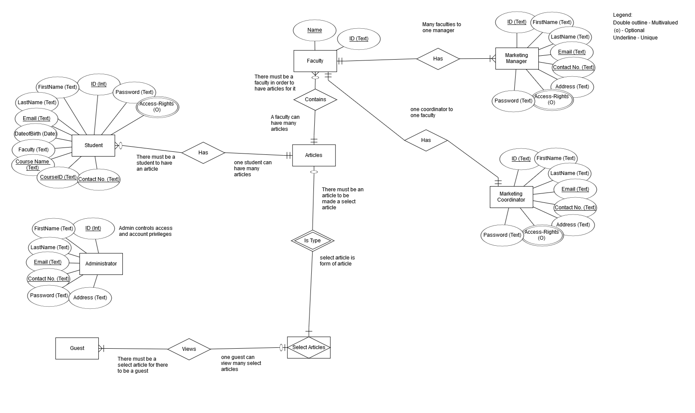

Figure 68 - Database ERD

# Testing

### Test Plan

|  |  |  |  |  |
| --- | --- | --- | --- | --- |
| Test | What is being tested | How | Test data used | Expected Results |
| 1 | user stories | Test that we have implemented the user’s request. | “ “ | Can the user do what they want to do? |
| 2 | Database | Check that the tables have the correct primary keys. | All tables within the database have the correct primary | Rows with a primary key should have a unique identifier. |
| 3 | Database | The user validation |  | Does it allow any information to be entered |
| 4 | Website & database | The connection between the database and the website | “” | Images, user data, and stored data will be shown on the website. |
| 5 | Website mobile and desktop | compatibility | I used my IPhone to see if the desktop browser was compatible with my mobile. | The desktop |
| 6 | Database Security | Can the public access the database. | Attempt to open and use the database as a public user. | The database should reject any unidentified user. |
| 7 | Can you see the images | Load the website and check the images | None. | Images loads successfully |
| 8 | Does the database link with the website | Load the web page and the data should show up |  | It displays the data from the database |
| 9 | Working links | Click on the links to see if it works | Click on links. | Taken to the right web page |
| 10 | Does the website load? | Open the URL in a browser | None | The website loads |
| 11 | Wrong password | Entered the wrong password. | “ no | “ Showed error |
| 12 | Long in | Enter the right password | Entered the right password | Allowed me to gain access to the system |
| 13 | Search system | Enter a word to search | Home | Take me to the home page. |
| 14 | Button | If the button take me to the appropriate link | Click on all the buttons | That all work well |
| 15 | Does the database allow public access. | Enter in random username and password. | Username: User123  Password: UserP12 | The database would reject public access. |
| 16 | Validation of input | Enter typical values, boundary value, values that should be rejected | User name I will be entering number instead. 1232 | Good data accepted, bad data rejected |
| 17 | Data control language | Deals with giving the authorization to users for manipulation and access to the data | No access was giving to the public | Only one group of people have the data control. |
| 18 | Database schema | how the data is going to be organized into a DB | There was a lot of table created | Everything entered into the database is formatted to the table. |

### Test Log

#### Marketing Manager

|  |  |  |
| --- | --- | --- |
| Able to log in and access the dashboard | Does it allow me to log in and access dashboard | Allows me to access dashboard |
| Able to reset my information | Does it allows me to change my information | Only can reset my password |
| Able to manage all the submissions | Do I have the control to manage all the submissions | Yes it allows me to manage all the submissions |
| Can I see all the submission | Does it allow me to see all the submission on the dashboard | Yes |
| Comments | ?? | ?? |
| Website mobile and desktop/ compatibility | Can I access the website from my phone | Yes it allows me to access the website from my phone |
| Does it allow me to produce Graph | Does it allow me to see statistics | Yes |
| Number of submissions | Number of submissions within each Faculty for each academic year | No |

#### Marketing Coordinator

|  |  |  |
| --- | --- | --- |
| Private messaging Students | Will I be able to contact students privately? | Yes I was able to private message a student. |
| Password reset. | If I forget or think someone knows my password will I be able to successfully change it. | Password reset was successful. |
| Access to all submissions within their faculty | Will I be able to access all documents uploaded within my faculty. | All documents within my faculty are only shown to me. |
| Managing submissions. | Will I be able to edit, rename and download submissions | Uploaded submissions are able to be edited within the website. |
| Leave comments on submissions | Will I be able to leave a comment on a submission? | Comments are able to be left on submissions. |
| Filter Submissions. | Filter submissions by date, students and search specific student submissions. | I was able to enter a specific date and filter the students that upload in that time frame. |
| Agree to term and conditions | Do the students agree to terms and conditions before a upload. | No, I am not given a confirmation that the student did agree to the terms and conditions. |
| Receive email notifications. | Will I be notified when I receive a notification? | Notification is not shown when I receive an email. |
| Timer for upload | Students are able to see the closure timer. | A correct timer is shown for the upload day. |
| Log-in successfully. | Can I log-in successfully. | Market Co-ordinators can log-in successfully. |

#### Administrator

|  |  |  |
| --- | --- | --- |
| Login and access the dashboard | I need to be able to login as an Administrator | YES |
| Changing information’s | password and other details | Only allows me to change my password and access my dashboard but change my address because there is none |
| Reset Password | link on the login form | YES |
| access to the user's control panel | so that I would be able to create, edit or remove accounts | YES |
| Change roles | Able to change a student to another role or anyone to another role | YES |
| Access to the system data | so I could set closure dates for each academic year | NO |
| Responsive to any devices | I could access it from all devices, including a mobile phone or a tablet. | YES |

#### Guests

|  |  |  |
| --- | --- | --- |
| Access to selected articles. | As a guest, I want to have access to selected articles so I can read them. | YES |

#### Students

|  |  |  |
| --- | --- | --- |
| login as a Student | control my account and use my privileges | I was able to control my account and use all my privileges |
| to change my password and other details | control my account and use my privileges |  |
| Uploading documents | As a student I need to be able to upload my coursework/document successfully in order for my work to be submitted and marked. | I can upload all my files but there is a limit and it up to three files I can upload at a time |
| Compatible on different devices. | Is the website compatible on a Tablet/Phone. | Yes the website is compatible with a tablet/ phone |
| Successfully changing my password. | If I forget or feel that someone knows my password, will I be able to change it. | Yes and also there is a limit encase someone is trying to guess your password they will get lock out |
| Confirmation message upload | When I upload a document, will I get a confirmation message? | No you won’t get a confirmation but there is a little message that will appear and say uploaded successfully |
| Upload Timer | Is a correct upload timer shown to the student. | Yes the time is correct |
| Uploading high quality images | Does it allow me to upload high quality and large images | yes it allows me to upload any files at any time |
| Uploading multiple documents | Will I be able to select more than one document and successfully upload. | yes I was able to upload any only three files which is the limit |
| Making changes to articles. | Will I be able to edit my articles before a final closure. | yes I was able to upload the file and edit the file |

#### Database

|  |  |  |
| --- | --- | --- |
| Downloading from the website. | Will I be able to retrieve a document from the database via the website? | Yes, the website successfully accesses the database and downloads the selected document. |

# Appendix

## System Access Details

### **User Components:**

Website Login for users: <http://www.uniwebamigos.eu/wp-login.php>

Email access for users: <https://pastas.serveriai.lt/>

### **Website Components:**

MySQL Access: <https://karosas.serveriai.lt/MyAdmin/>

Username: vandenis_tester

Password: UniwebAmigos

FTP Access:

FTP: //uniwebamigos.eu (or server 79.98.24.7)

Username: [uniwebamigos@uniwebamigos.eu](mailto:uniwebamigos@uniwebamigos.eu)

Password: uniwebamigos

## User Account Details

### **Students:**

Student 1 from Faculty 1:

Email Username: [studentf1@uniwebamigos.eu](mailto:studentf1@uniwebamigos.eu)

Email Password: studentfaculty1

Web Username: student001

Web Password: studentfaculty1

Student 2 from Faculty 1:

Email Username: [studentf1-1@uniwebamigos.eu](mailto:studentf1-1@uniwebamigos.eu)

Email Password: studentfaculty1

Web Username: student003

Web Password: studentfaculty1

Student 1 from Faculty 2:

Email Username: [studentf2@uniwebamigos.eu](mailto:studentf2@uniwebamigos.eu)

Email Password: studentfaculty2

Web Username: student002

Web Password: studentfaculty2

Student 2 from Faculty 2:

Email Username: [studentf2-1@uniwebamigos.eu](mailto:studentf2-1@uniwebamigos.eu)

Email Password: studentfaculty2

Web Username: student004

Web Password: studentfaculty2

Additional Student Accounts for Faculty 1:

|  |  |
| --- | --- |
| Web Username: | Web Password: |
| student005 | student |
| student006 | student |
| student007 | student |
| student008 | student |
| student009 | student |
| student010 | student |
| student011 | student |
| student012 | student |

### **Marketing Coordinators**

Marketing Coordinator Faculty 1:

Email Username: [marketing-coordinator-1@uniwebamigos.eu](mailto:marketing-coordinator-1@uniwebamigos.eu)

Email Password: marketing-coordinator-1

Web Username: marketingcoordinator001

Web Password: coordinator

Marketing Coordinator Faculty 2:

Email Username: [marketing-coordinator-2@uniwebamigos.eu](mailto:marketing-coordinator-2@uniwebamigos.eu)

Email Password: marketing-coordinator-2

Web Username: marketingcoordinator002

Web Password: coordinator

### **Marketing Manager:**

Email Username: [marketing-manager@uniwebamigos.eu](mailto:marketing-manager@uniwebamigos.eu)

Email Password: marketing-manager

Web Username: marketing-manager001

Web Password: manager

### **Administrator:**

Email Username: [admin@uniwebamigos.eu](mailto:admin@uniwebamigos.eu)

Email Password: uniweb-admin

Web Username: uniwebadmin

Web Password: uniwebadmin

### **Master Administrator:**

Web Username: pegaguadmin

Web Password: masteradmin

### **Subscriber:**

Email Username: [subscriber@uniwebamigos.eu](mailto:subscriber@uniwebamigos.eu)

Email Password: subscribersubscriber

Web Username: subscriber

Web Password:  subscriber

## Charts & Diagrams

### **Gantt Chart**

Figure 69 - Uniweb Gantt

### **Burndown Chart**

Figure 70 - Uniweb Burndown

## Sprints

### Sprint One (Week One)

* All login need to be created for each of the users (Students, Marketing Manager, Marketing Coordinator, Administrator). This will involve them when they login taking them to their required pages that have been set for them.
* Then each of the users will need to be able to edit the passwords and their other personal details.
* Then the admin can create edit and delete accounts and set the roles for these accounts.

### Sprint Two (Week Two)

* To start the student page by making sure that they can uploads image and files and to be able to upload multiple of them.
* To start the marketing coordinator page there needs to be able to comment on any student submission made and have 14-day time to comment.
* To start the marketing manager, page their needs be a way to see all submissions made so they are able to keep track of all the submissions that have been made for each of the students.

### Sprint Three (Week Three)

* Making a way of showing users when they login of when they were last logged in for security reasons
* Start to make the site more responsive and mobile friendly so users can use any device.

### Sprint Four (Week Four)

* Adding to the student page is a way to edit submissions before its closure date.
* Adding a way that the marketing coordinator can receive emails whenever a new submission is made.

### Sprint Five (Week Five)

* On the marketing coordinator page, they need to view all submissions made within their faculty’s and make sure that they can only see their own faculty and not interfere with any others.
* On the marketing manager page create a page, where they can see all the submissions that have been made so they can keep track and manage things better.

### Sprint Six (Week Six)

* Making a page where the marketing manager can see the statistics of the site from the number of submissions made to percentages of the faculty’s that made the submissions etc.
* Making the terms and conditions for the site then making the students accept these terms and conditions before they can make a submission.

### Sprint Seven (Week Seven)

* Making a page where the administrator can see the statistics of the site from number of users, most active users and most visited pages for example.
* Then making a way of the marketing manager being able to download all the submissions made into one zipped folder.

## Meeting Minutes

### **Meeting 1**

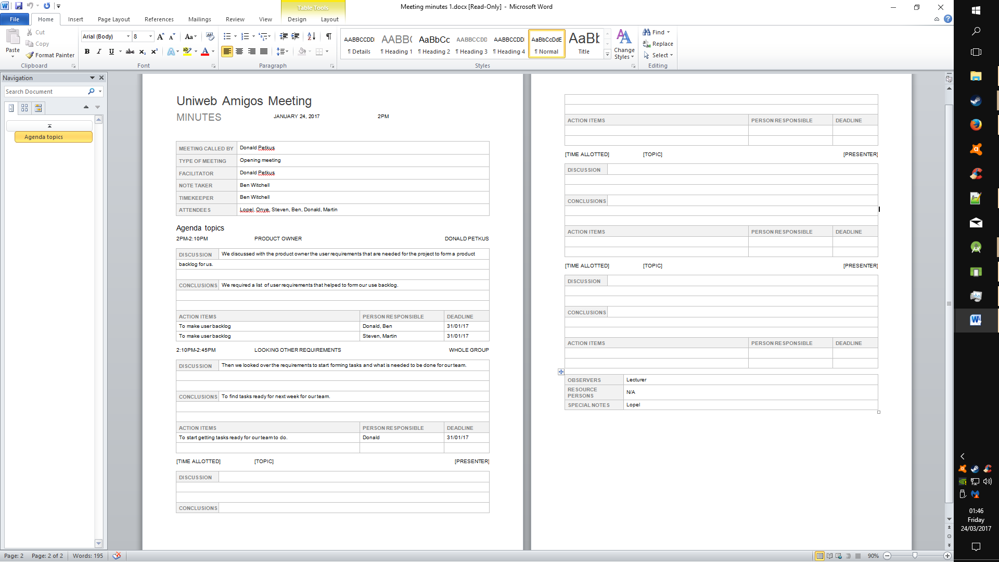

Figure 71 - Minutes 1 Screen 1



Figure 72 - Minutes 1 Screen 2

### **Meeting 2**

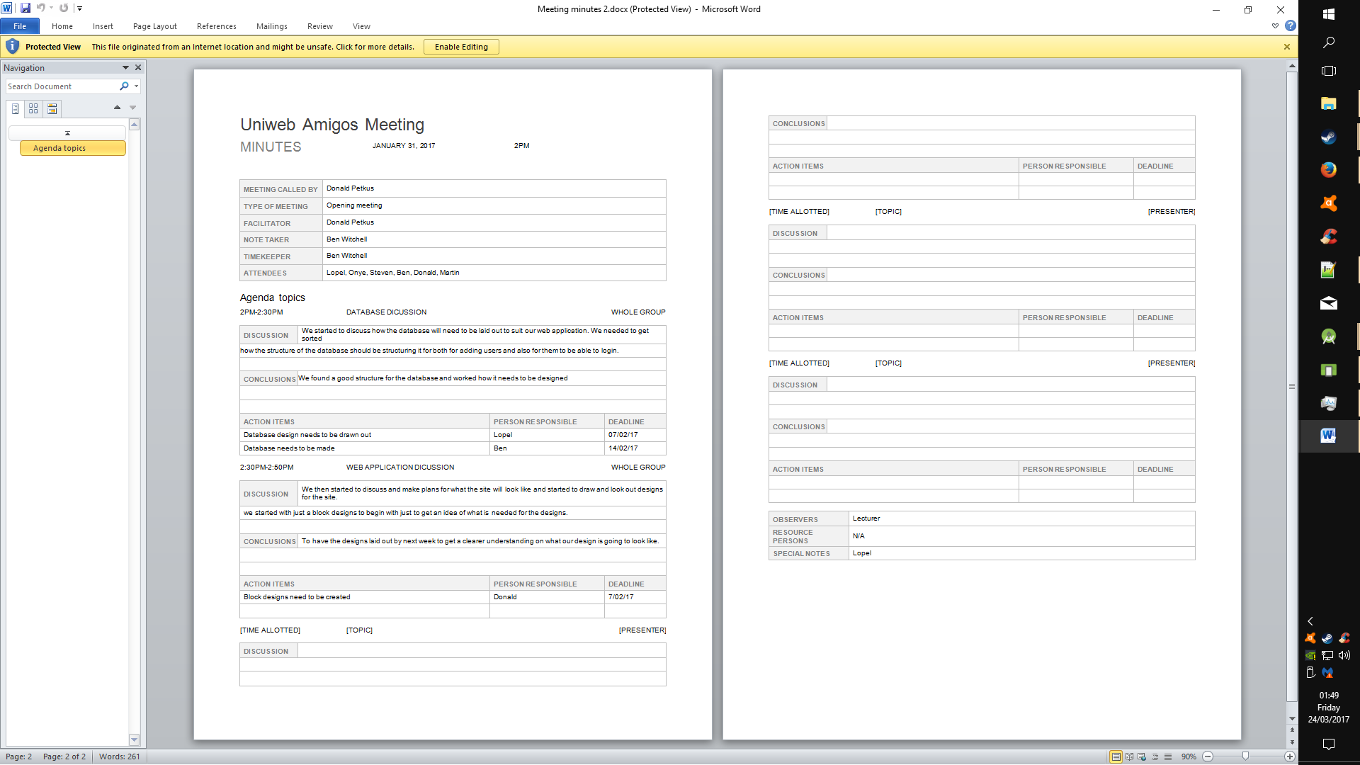

Figure 73 - Minutes 2 Screen 1



Figure 74 - Minutes 2 Screen 2

### **Meeting 3**

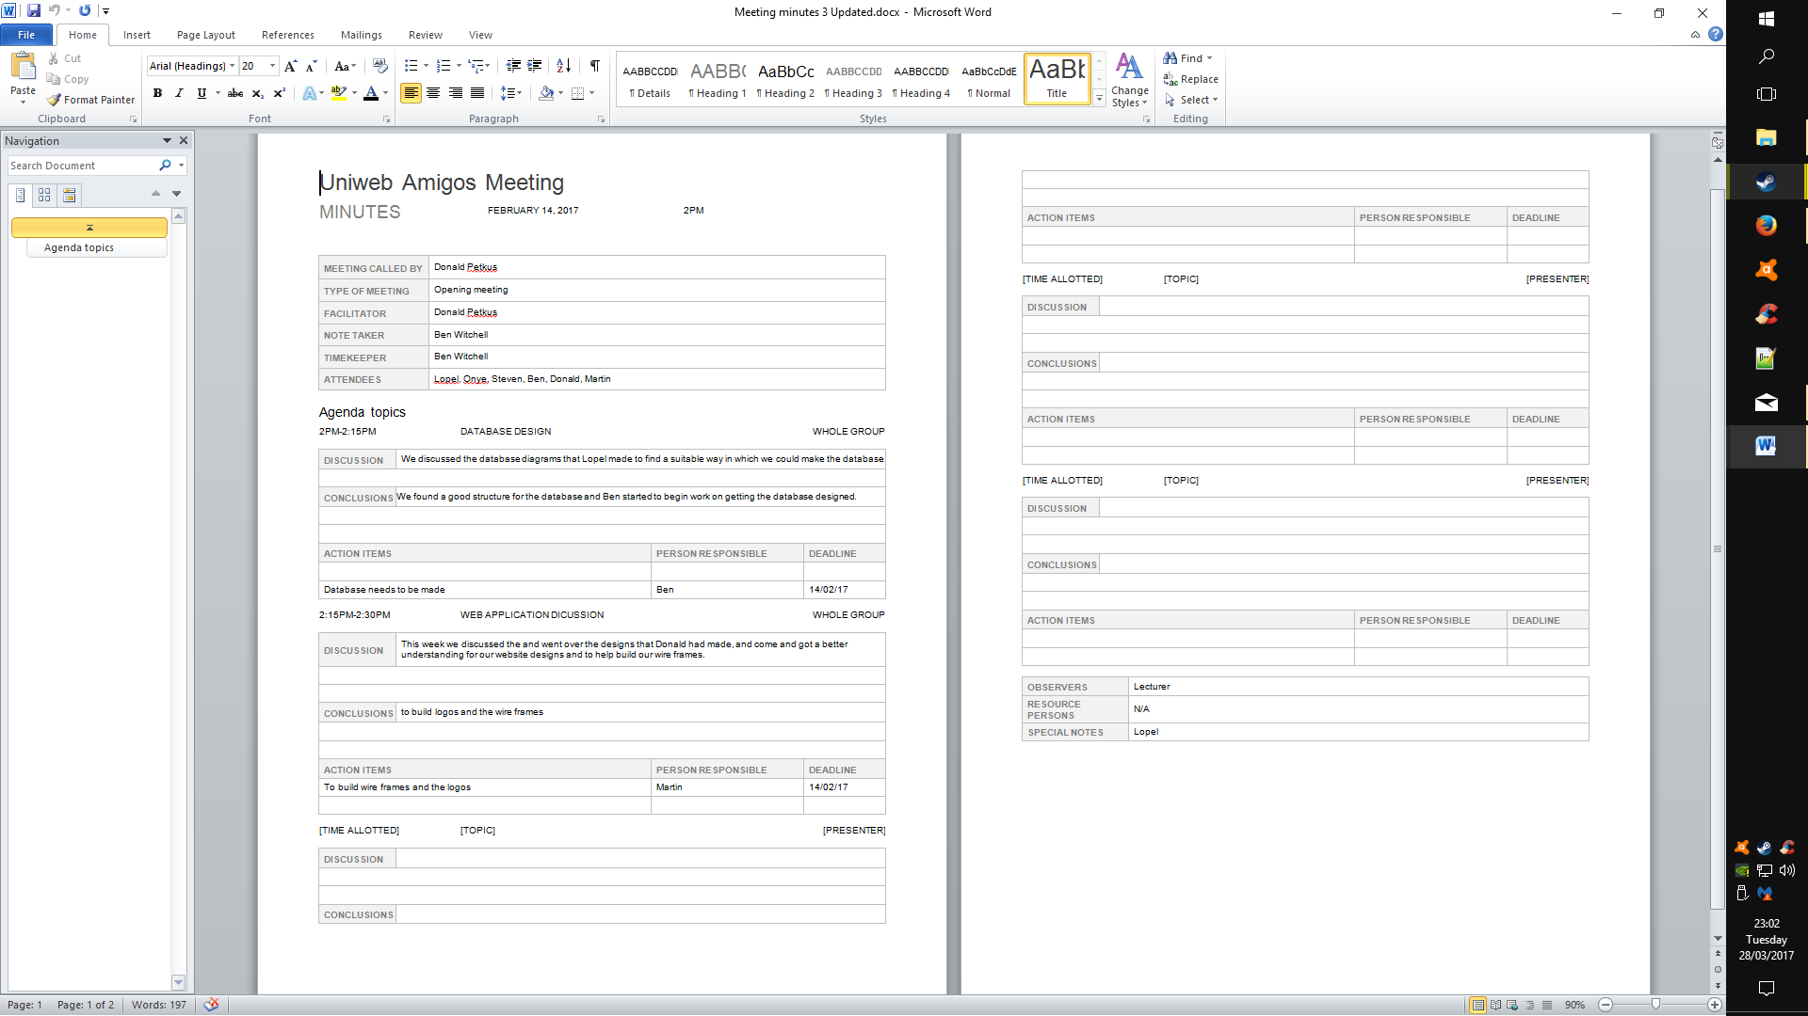

Figure 75 - Minutes 3 Screen 1



Figure 76 - Minutes 3 Screen 2

### **Meeting 4**

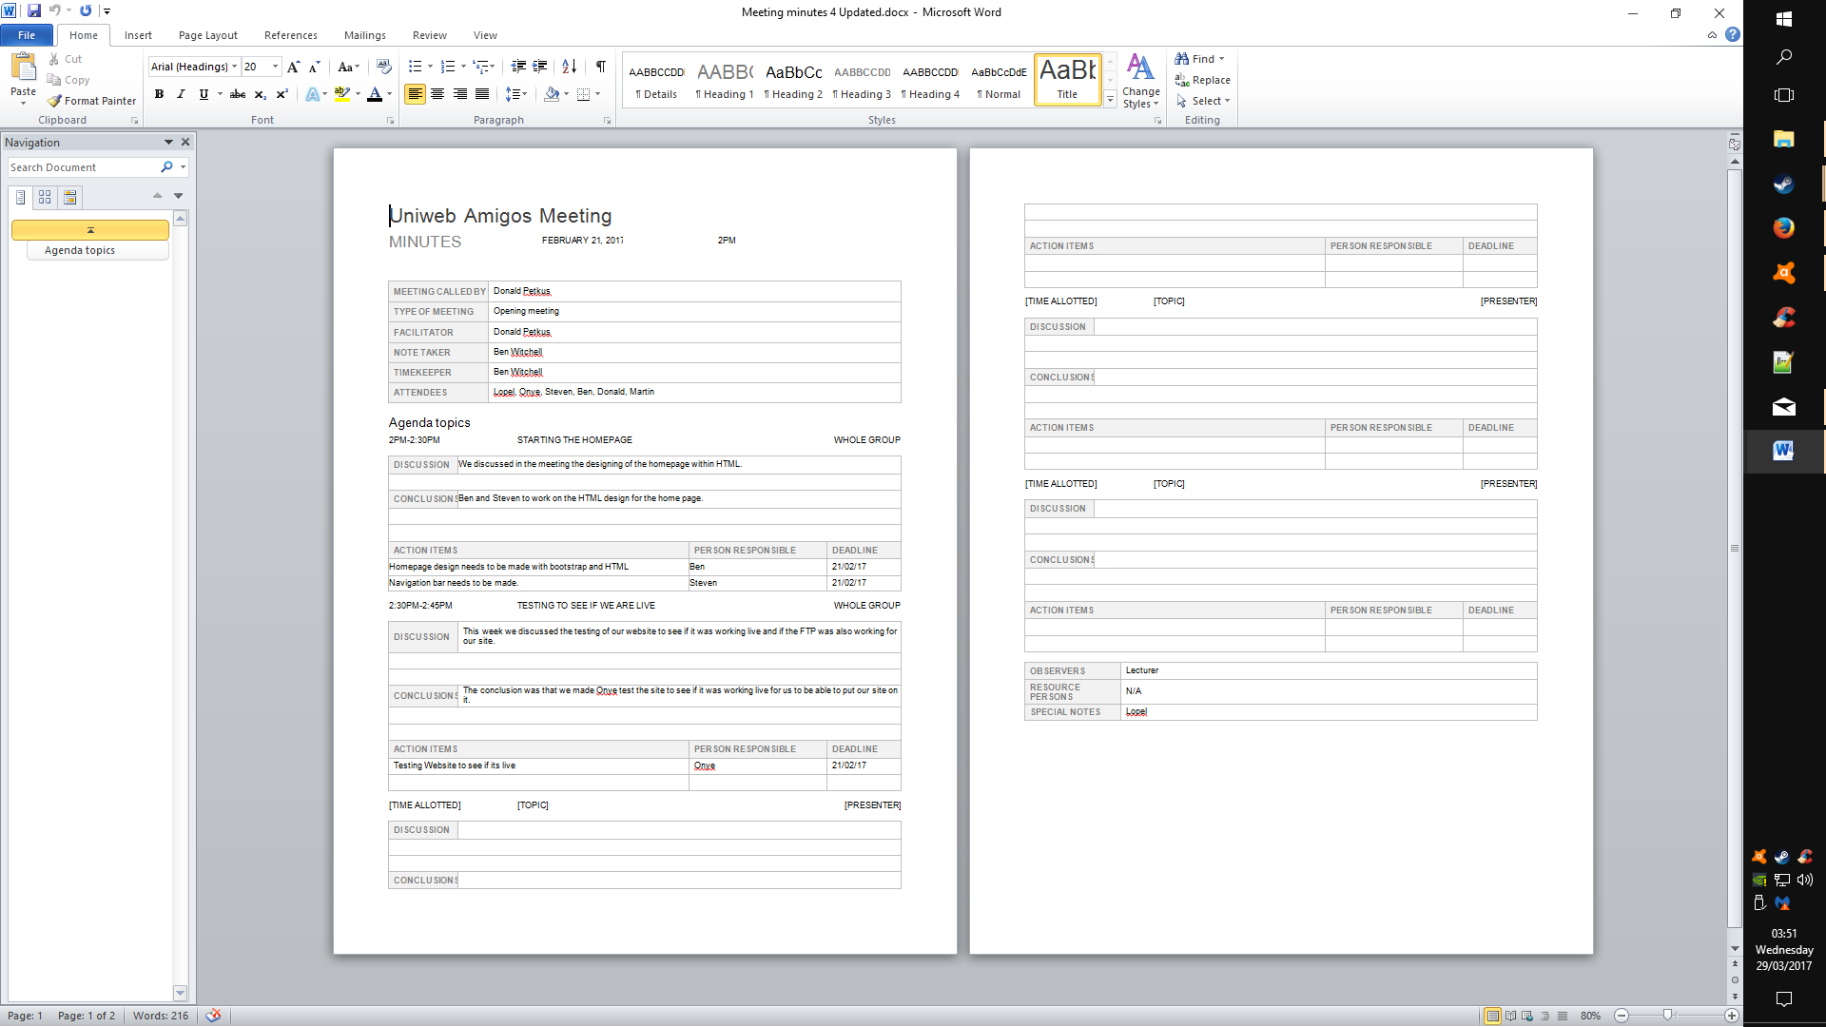

Figure 77 - Minutes 4 Screen 1



Figure 78 - Minutes 4 Screen 2

### **Meeting 5**

Figure 79 - Minutes 5 Screen 1

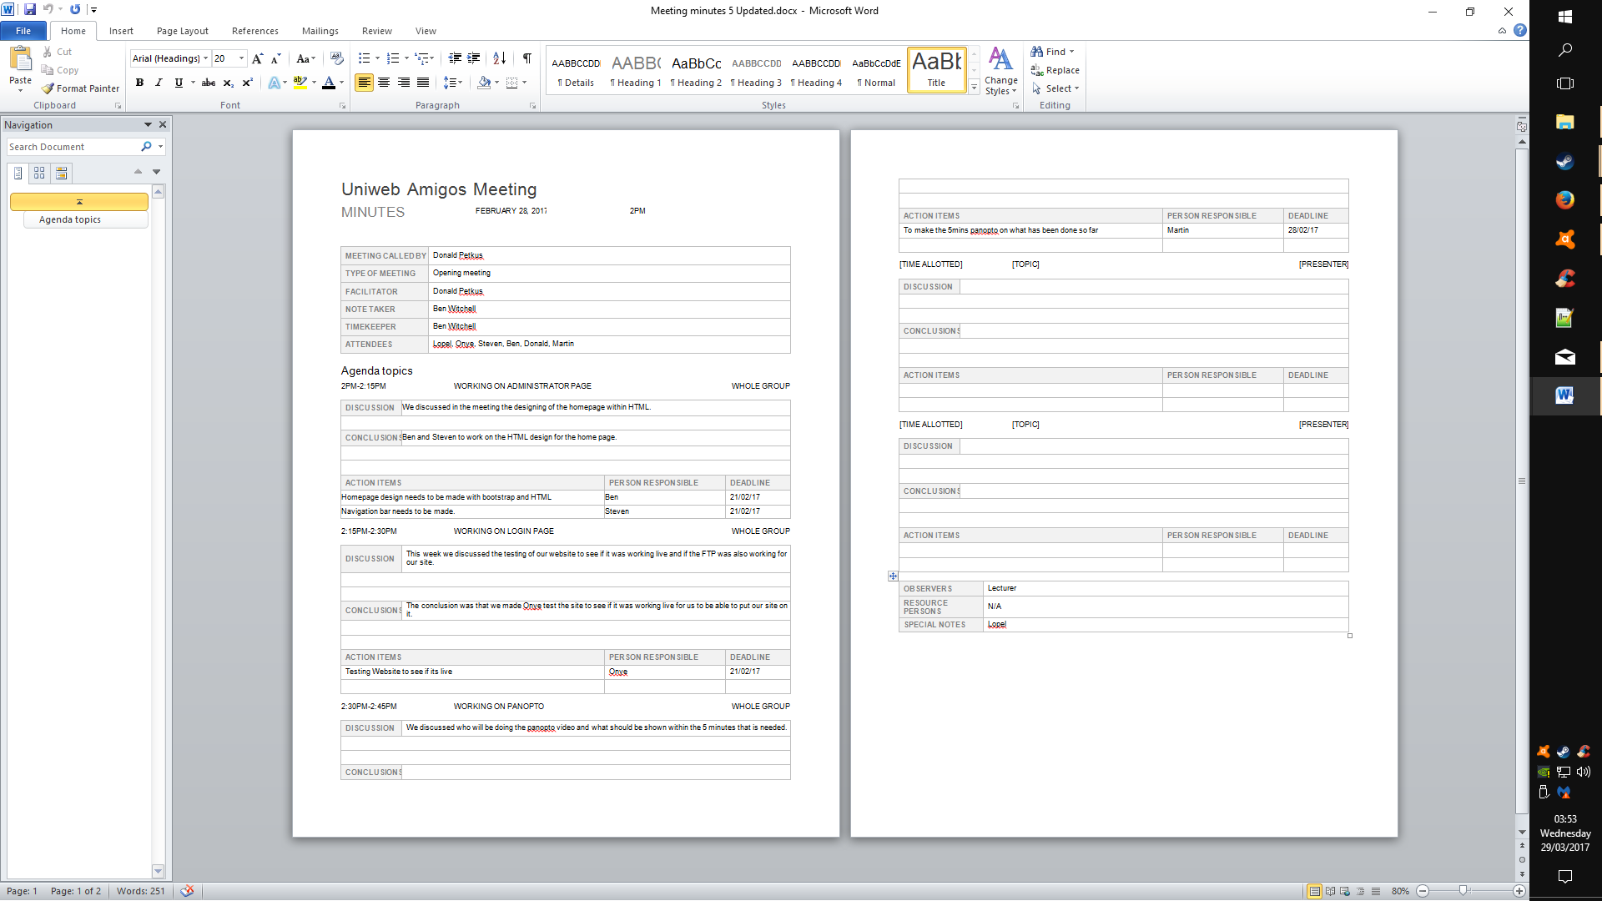

Figure 80 - Minutes 5 Screen 2

### **Meeting 6**

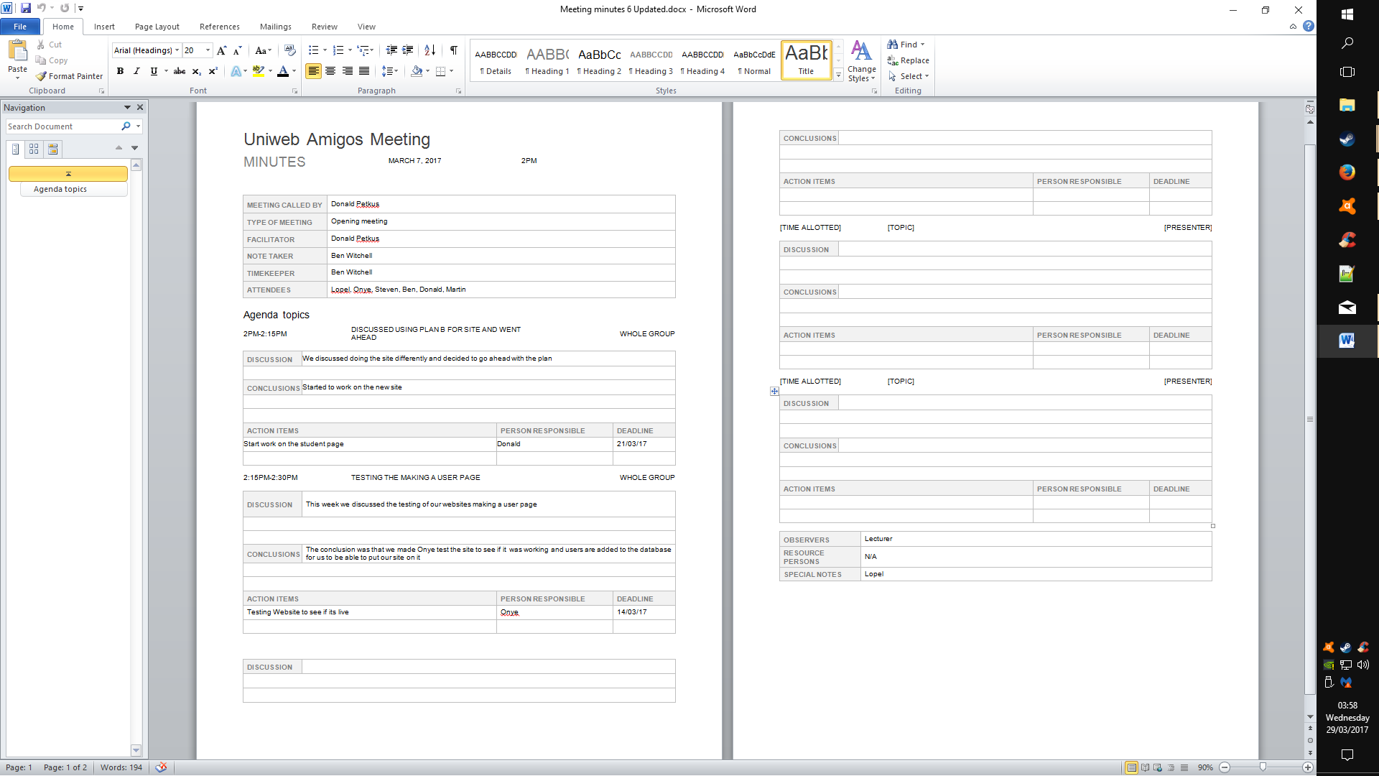

Figure 81 - Minutes 6 Screen 1



Figure 82 - Minutes 6 Screen 2

### **Meeting 7**

Figure 83 - Minutes 7 Screen 1

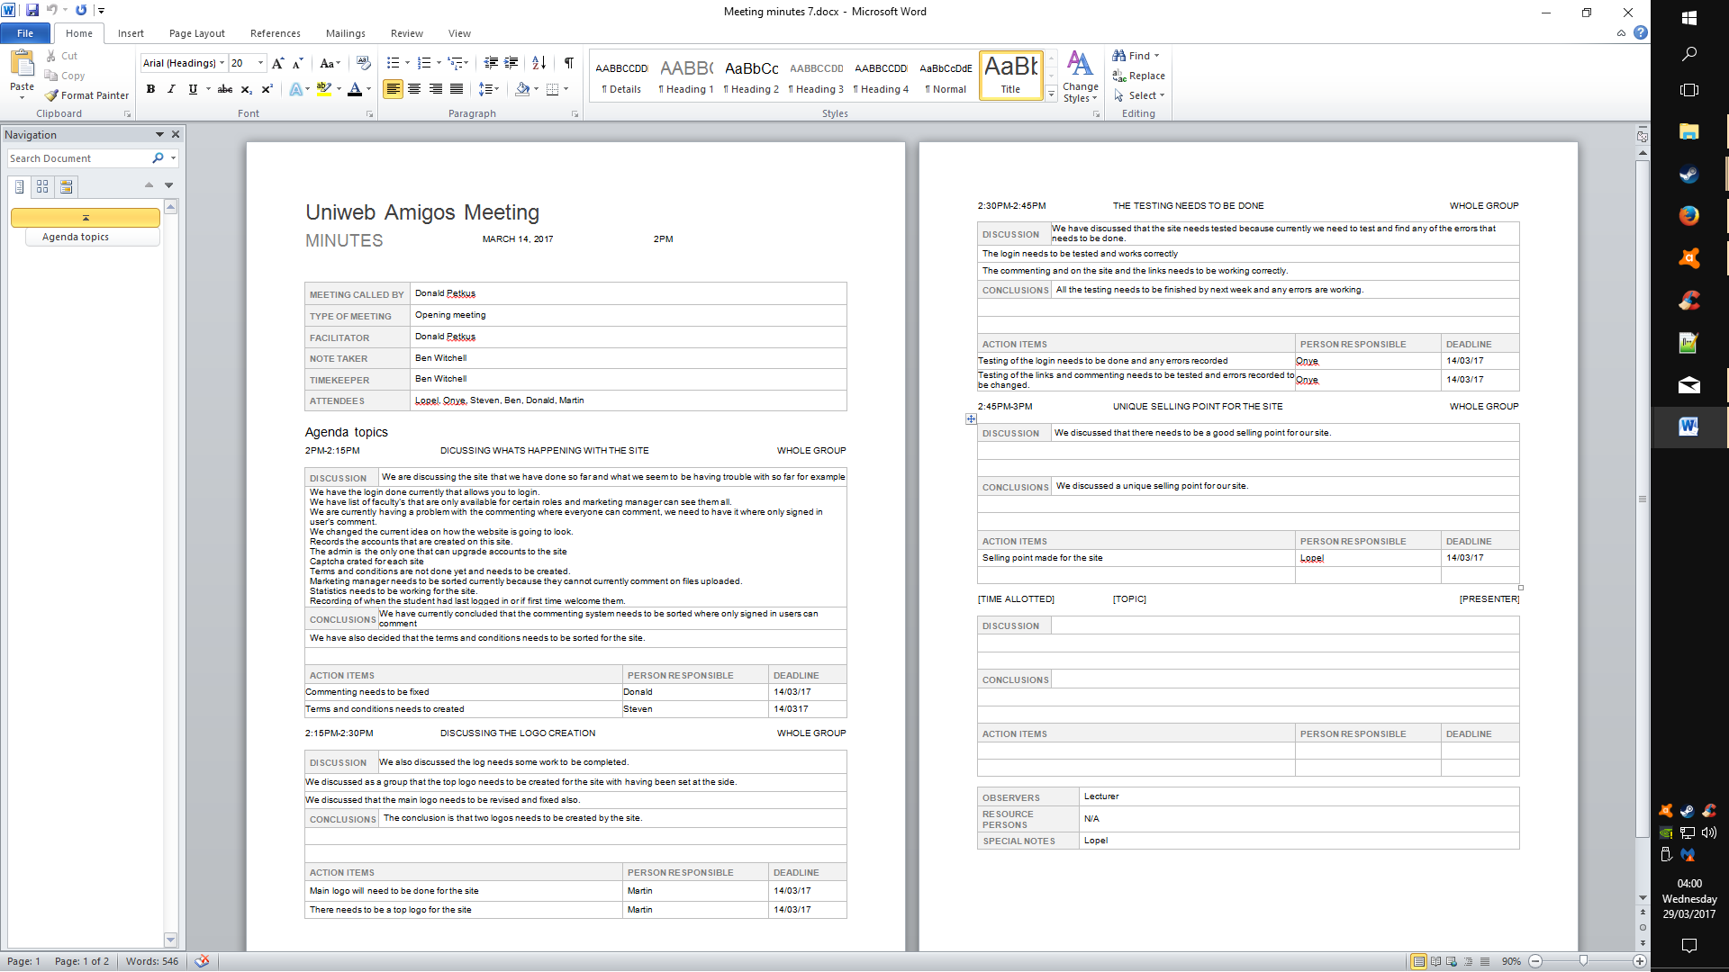

Figure 84 - Minutes 7 Screen 2

### **Meeting 8**

Figure 85 - Minutes 8 Screen 1

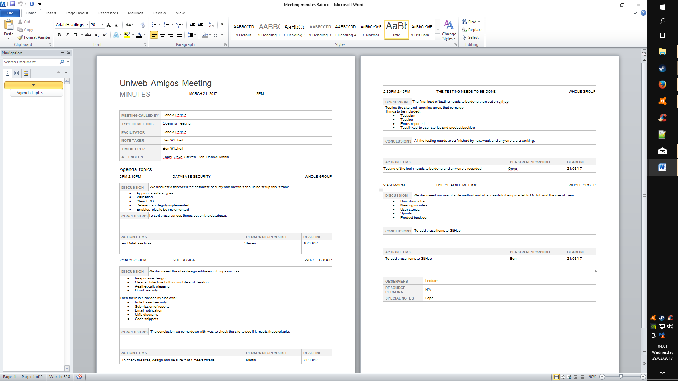

Figure 86 - Minutes 8 Screen 2

## Website Privacy Policies

**What is this Privacy Policy for?**

This privacy policy is for this website and governs the privacy of its users who choose to use it.

The policy sets out the different areas where user privacy is concerned and outlines the obligations & requirements of the users, the website and website owners. Furthermore the way this website processes, stores and protects user data and information will also be detailed within this policy.

**The Website**

This website and its owners take a proactive approach to user privacy and ensure the necessary steps are taken to protect the privacy of its users throughout their visiting experience. This website complies with all UK national laws and requirements for user privacy.

**Use of Cookies**

This website uses cookies to better the users experience while visiting the website. Where applicable this website uses a cookie control system allowing the user on their first visit to the website to allow or disallow the use of cookies on their computer / device. This complies with recent legislation requirements for websites to obtain explicit consent from users before leaving behind or reading files such as cookies on a user's computer / device.

Cookies are small files saved to the user's computer’s hard drive that track, save and store information about the user's interactions and usage of the website. This allows the website, through its server to provide the users with a tailored experience within this website.

Users are advised that if they wish to deny the use and saving of cookies from this website on to their computers hard drive they should take necessary steps within their web browsers security settings to block all cookies from this website and its external serving vendors.

## Figures

Figure 1 - Student Dashboard 14

Figure 2 - Upload Validation 14

Figure 3 - Upload Selection 14

Figure 4 - Login Input Validation 15

Figure 5 - Student Notification Panel 16

Figure 6 - External Email Client 16

Figure 7 - Mock-up 2 - Login 17

Figure 8 - Mock-up 1 (Home) 17

Figure 9 - Mock-up 4 - Password Reset 17

Figure 10 - Mock-up 3 - Coordinator Page 17

Figure 11 - Mock-up 5 - Student Upload 18

Figure 12 - Mock-up 6 - Student Dashboard 18

Figure 13 - Home Page V1 19

Figure 14 - Home Page v2 19

Figure 15 - Login 20

Figure 16 - Login 2 20

Figure 17 - Account Recovery 20

Figure 18 - Article View 21

Figure 19 - Article Browser 21

Figure 20 - Admin Dashboard Demo 22

Figure 21 - Redux Home 23

Figure 22 - Redux Home 2 23

Figure 23 - Redux About 24

Figure 24 - Redux Article 25

Figure 25 - Redux Privacy 25

Figure 26 - Redux Login 26

Figure 27 - Redux Recovery 26

Figure 28 - Redux User Account 27

Figure 29 - Redux User Notifications 28

Figure 30 - Redux User Settings 28

Figure 31 - Redux Student Dashboard 29

Figure 32 - Redux Admin Dashboard 29

Figure 33 - Redux Coordinator Dashboard 30

Figure 34 - Redux Manager Dashboard 30

Figure 35 - Android Platform Statistics 31

Figure 36 - Mobile View Home 31

Figure 37 - Mobile View Dropdown 31

Figure 38 - Mobile View Viewing an Article 32

Figure 39 - Mobile View Finding an Article 32

Figure 40 - Mobile View Writing Comment 33

Figure 41 - Mobile View Comment Awaiting Moderation 33

Figure 42 - Mobile View Invalid Login Prevented 34

Figure 43 - Mobile View Login Validation 34

Figure 44 - Mobile View Admin Analytics Dash 35

Figure 45 - Listen to this 36

Figure 46 - Article Accessibility 36

Figure 47 - Bright Blue Colour Scheme 37

Figure 48 - Bright Blue Simulator 37

Figure 49 - Dark Grey Colour Scheme 38

Figure 50 - Dark Grey Simulator 38

Figure 51 - Very Dark Grey Simulator 39

Figure 52 - Very Dark Grey Colour Scheme 39

Figure 53 - Logo Assets Shields & Wreaths 40

Figure 54 - Logo Assets Handshake 2 40

Figure 55 - Logo Assets Handshake 1 40

Figure 56 - Logo Test 2 41

Figure 57 - Logo Test 1 41

Figure 58 - Logo Test 3 41

Figure 59 - Logo Alpha 1 41

Figure 60 - Logo Alpha 2 41

Figure 61 - Logo Alpha 3 41

Figure 62 - Logo Beta 41

Figure 63 - Logo Beta 3 41

Figure 64 - Logo Beta 2 41

Figure 65 - Logo Beta 1 41

Figure 66 - Logo Final Main 42

Figure 67 - Logo Final Banner 42

Figure 68 - Database ERD 43

Figure 69 - Uniweb Gantt 50

Figure 70 - Uniweb Burndown 51

Figure 71 - Minutes 1 Screen 1 53

Figure 72 - Minutes 1 Screen 2 54

Figure 73 - Minutes 2 Screen 1 55

Figure 74 - Minutes 2 Screen 2 56

Figure 75 - Minutes 3 Screen 1 57

Figure 76 - Minutes 3 Screen 2 58

Figure 77 - Minutes 4 Screen 1 59

Figure 78 - Minutes 4 Screen 2 60

Figure 79 - Minutes 5 Screen 1 61

Figure 80 - Minutes 5 Screen 2 62

Figure 81 - Minutes 6 Screen 1 63

Figure 82 - Minutes 6 Screen 2 64

Figure 83 - Minutes 7 Screen 1 65

Figure 84 - Minutes 7 Screen 2 66

Figure 85 - Minutes 8 Screen 1 67

Figure 86 - Minutes 8 Screen 2 68